Walk 63 – Brown Edge – 3.0 miles, bit of climbing

Park at the last car park on Redmires Road / Long Causeway (north of Redmires top reservoir)
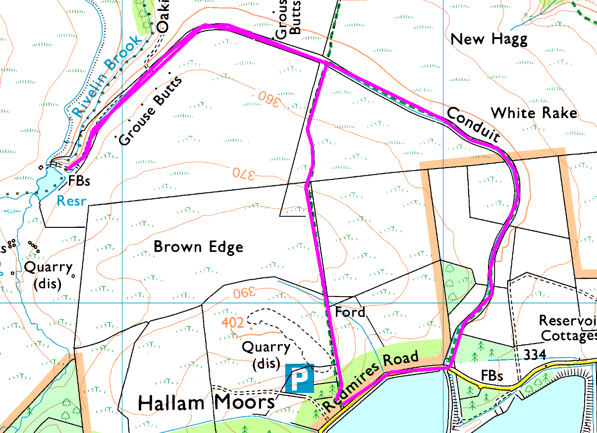
Clockwise:
From the car park, go over the stile onto the footpath and head uphill. You soon emerge from the trees and cross open (boggy) moorland with a dip to cross the first stream before climbing up to Brown Edge and some excellent views to the north and east.
Keep going down besides the wall till you reach the bridge over the conduit. If you want the short walk, turn right here; otherwise turn left and follow the conduit to the small feeder reservoir which holds water from Rivelin Brook.
Return along the conduit as it follows the side of the hill, then turn right and follow the road back to the car park.
Risks:
- Short bit of road walking – often surprisingly busy, so keep right.
- Water – the conduit is unfenced and steep sided, but the path is quite wide and level.
- Mud – this is a peat moor, so it is wet even in summer.
- Uneven surfaces going out – the path beside the conduit is firm and level though.
For a shorter, flat walk, keep to the road and do some bird watching!

