62 – High Wincobank – 2.5 miles

We have approached Wincobank Fort from Firth Park and from Roman Ridge, so here is a walk starting in Concord Park and visiting the Ridge and the Fort, following paths we have largely used before (just not in this order!)
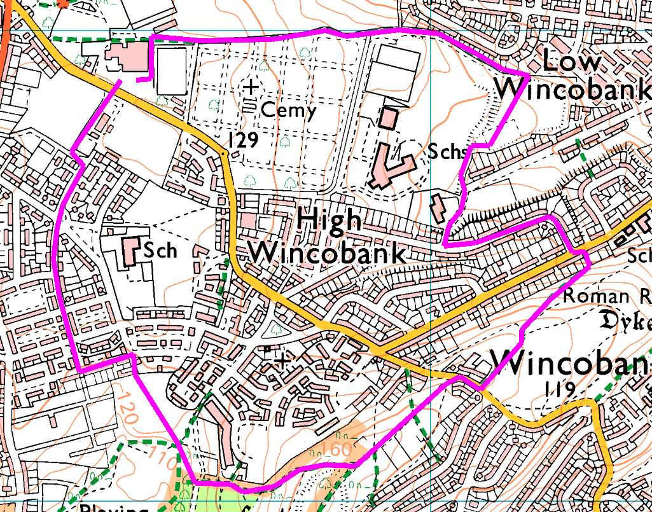
From Concord, follow the path between the cemetery and the golf club round as far as the old playing fields. Sharp right across the fields and find the path in the corner through to Fife Street.
Turn left past the school entrance and out onto Newman Drive. Turn left and follow round to the end, then cross Newman Road diagonally to the footpath up Roman Ridge. Cross Jenkin Road with care, and look at the searchlight monument, before heading up to the fort, then bear right and drop down, turning right at the bottom. Go straight on at the junction, up the bank and cross the playing field, out onto Bracken Road. Turn left on Clover Gardens and then right and just follow Foxglove Road through to the Steel City bowling club and Concord.
Risks
- 3 major road crossings
- Paths may be muddy or slippery if wet.

