67 – Rivelin and Den Bank – 2.2 miles

Another short walk, but with lots of climbing (or not, for the short walk). We start off at Liberty Hill in Stannington, cross the Rivelin and climb towards Bell Hagg. After touching the Manchester Road, we skirt round Den Bank and drop to the Hagg before recrossing the river and climbing the steps and a steep slope back to the minibus.
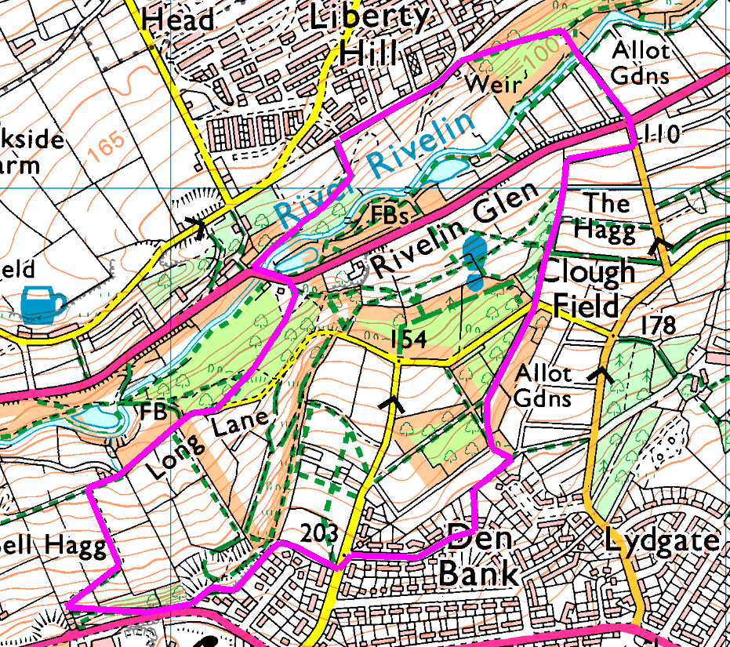
Anticlockwise
We park at the side of the road, just at the top of the footpath which leads us down to Rivelin Bridge. Mind your footing as the path here has an adverse camber!
Cross the bridge and the road with extreme care then take the footpath on the right which leads up to Long Lane. At the end of the lane go straight on along the track then take the first footpath on the left and zig-zag up to Manchester Road. At the road, take the other footpath behind the houses to Hagg Lane. Cross and follow Den Bank Drive around to the footpath beside number 53.
By the allotments, sharp left then bear right to cross Long Lane near the Alpaca farm, and straight down the back of Clough Field and The Hagg to emerge onto Hagg Hill and Rivelin Valley Road. Take the path between the allotments, cross the bridge and straight up the steps and slope, then left on the road to return to the car.
Risks
- 3 road crossings, 1 on a blind bend so take care. Paths so may be muddy or slippery if wet.
- Quite a lot of paths, so try not to get lost!

