60 – Westwood Park – 2.2 miles

This walk takes in Thorncliffe Wood and Westwood Country Park; it is quite short because we are starting a long way from the stadium, but there are several shorter options and a couple of longer ones! The walk is entirely off road apart from about 30 yards through some houses.
Start in the car park of Thorncliffe Leisure Centre or the Paces car park – since I planned this route, they have put in barriers at the leisure centre!
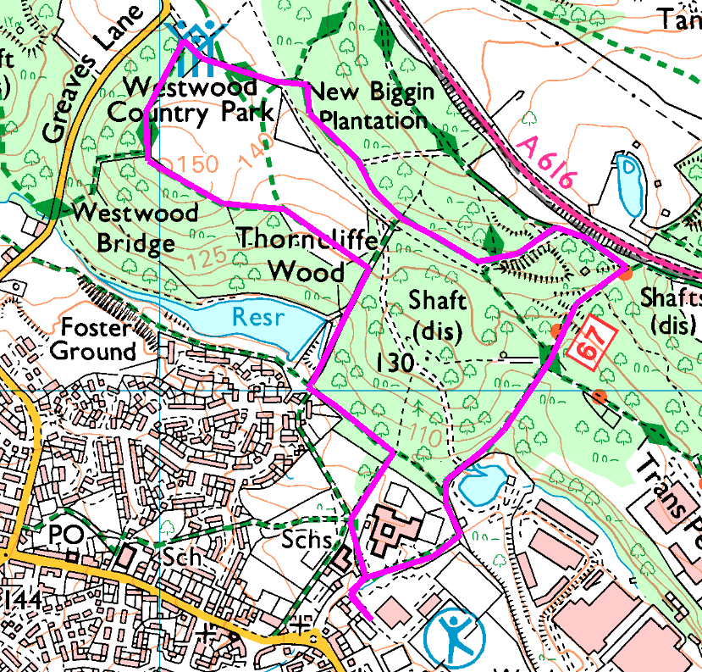
Anticlockwise
From the car park, head out to the path between the leisure centre and Paces and turn to walk downhill. Through the barrier, bear left and then follow the path bearing right up the hill. As you approach the road, turn left. Bear left and head through New Biggin Plantation then follow the TPT as it bears left again.
Keep the trees on your left as you head down then turn right on the path across the middle of the dam.
Turn left behind the houses down the hill, then right at the cross-paths and follow round the allotment, or go straight across the front of the houses into another footpath which returns you to the front of Paces.
Risks
- No road crossings. All woodland and grass paths so may be muddy or slippery if wet.
- Quite a lot of paths, so try not to get lost!

