53 – Damflask South – 2.3 miles plus

Start on New Road, preferably near the junction with Oaks Lane. The walk is 2.3 miles but if you park on the dam, it’s another half mile each way!
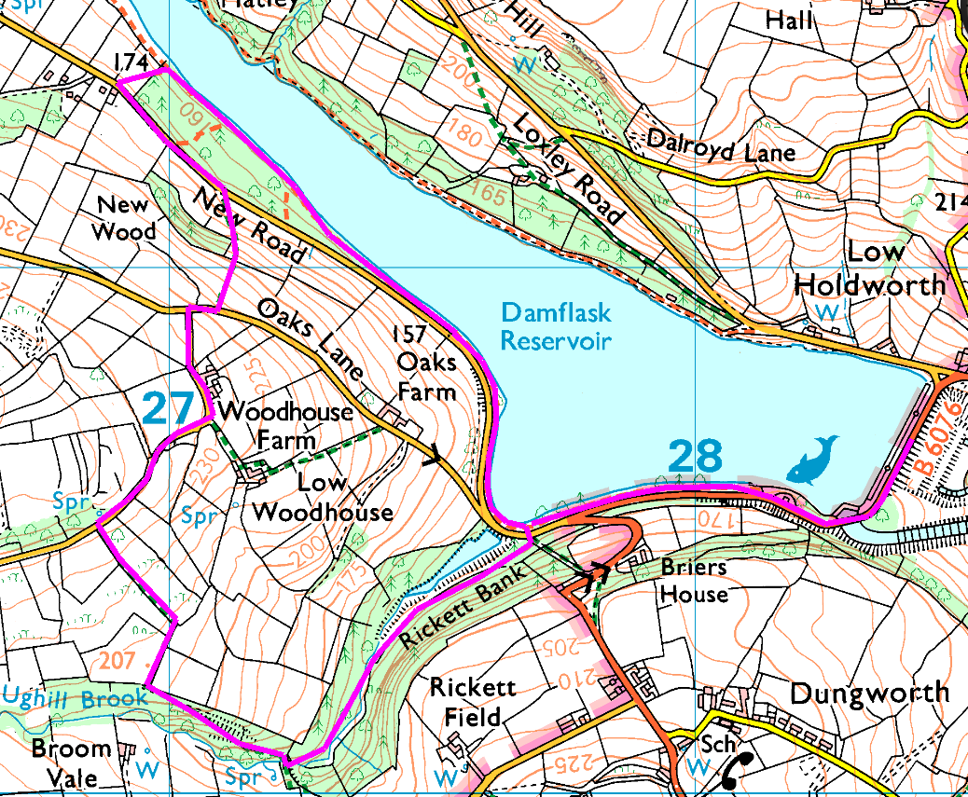
Anticlockwise
Head North along the side of the reservoir till you leave the road, then watch out for a path on the left. Ideally you want the one just as you leave the trees (which should be the third).
Follow this up to the road and turn left, then as the road bends left, find the footpath on the right. Cross the stile and head for the corner of the trees, then continue uphill to Oaks Lane. Turn right then left onto Ughill Wood Lane and follow till you find a footpath which drops away on the left.
Follow this as it bends right then left into the trees, then as it bends right again find the footpath on your left which follows the brook down through the trees. If you start climbing you’ve gone too far!
Follow this path all the way back to New Road, and return to the minibus.

Risks
- Fairly steep climbs and descents
- Paths may be muddy or slippery if wet.
- A few minor road crossings

