52 – The Birley Stone – 2.3 miles Hilly

Start on Midhurst Road, S6 1EY, in the layby near the nursing home.
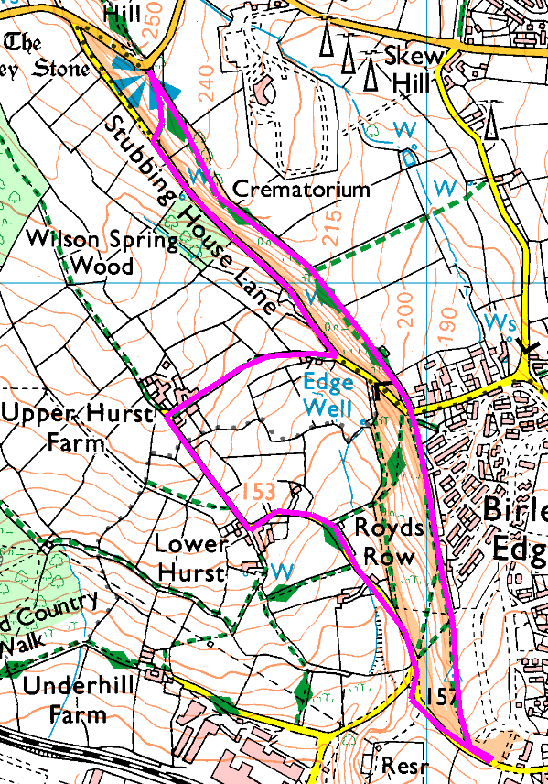
Clockwise
Start heading North along the road – and keep going till you get to Upper Hurst Farm (which is the end of the road). Take the footpath on the right and climb to Stubbing House Lane, then turn left and follow the lane for 500 metres before taking the footpath on the right to go steeply uphill to the Birley Stone. You may be more familiar with this as Whalejaw Hill or Jawbone Hill, but the view is the same whatever you call it.
We now turn back and follow the top of the ridge, all the way back to the minibus.

For a shorter walk, go out to the main road, turn left and left again into Fox Hill Crescent and follow round to Edge Well Crescent, then explore the options for getting onto Back Edge (that’s what we will be using as the return path).

Risks
- Fairly steep climb
- Paths may be muddy or slippery if wet.
- One minor road crossing
- Take care on Midhurst Road – cars drive too fast round the very sharp bend.

