51 – Chapeltown Park – 2.5 miles

Start on Smithywood Business Park, S35 1QN, near the roundabout. Normally you can park at the bottom of the hill, but at present there’s building work so this may be blocked.
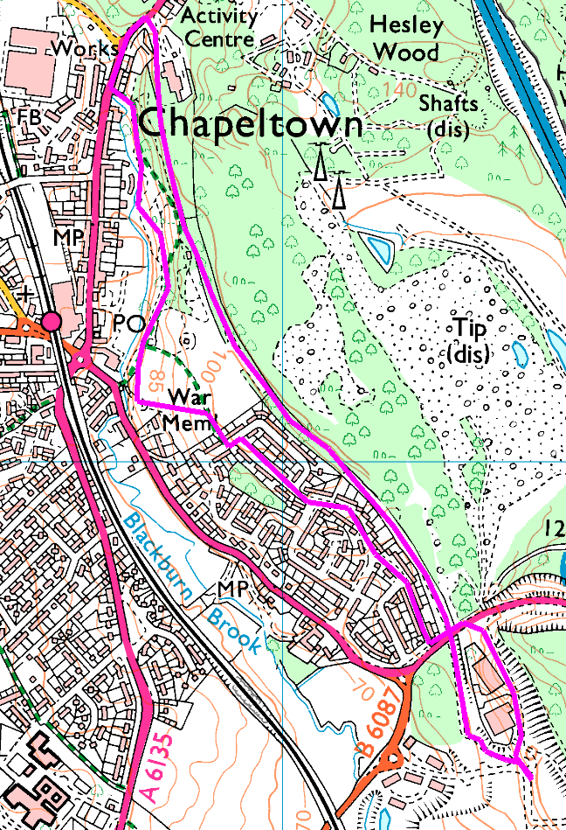
Anticlockwise (except the last little bit)
We start by heading North, behind Powerstar along the cycle route. This takes us under Cowley Hill Road and eventually leads to Coppice Rise and Station Road. You will see Chapeltown Park on the left, and for a shorter walk you can just go into the park and rejoin the return leg of the walk here.
On Station Road, turn left and after a hundred yards turn left again into the park. Head down through the trees and find the war memorial, then leave the park in the gap between the houses
Turn left and then right onto Woodburn Drive and follow this and Cowley Drive right through to Cowley Hill. Turn left and cross over the outbound route, then right into the business park. For some obscure reason, they put the toucan crossing above the junction, you should use this if the road is busy.
Follow the road back to the minibus.

Risks
- 1 major road crossings, use the Toucan!
- Paths may be muddy or slippery if wet.

