50 – Stannington Stoneface – 2.5 miles

If you have been with us to Stannington before, you will recognise parts of this walk but maybe not in this direction.
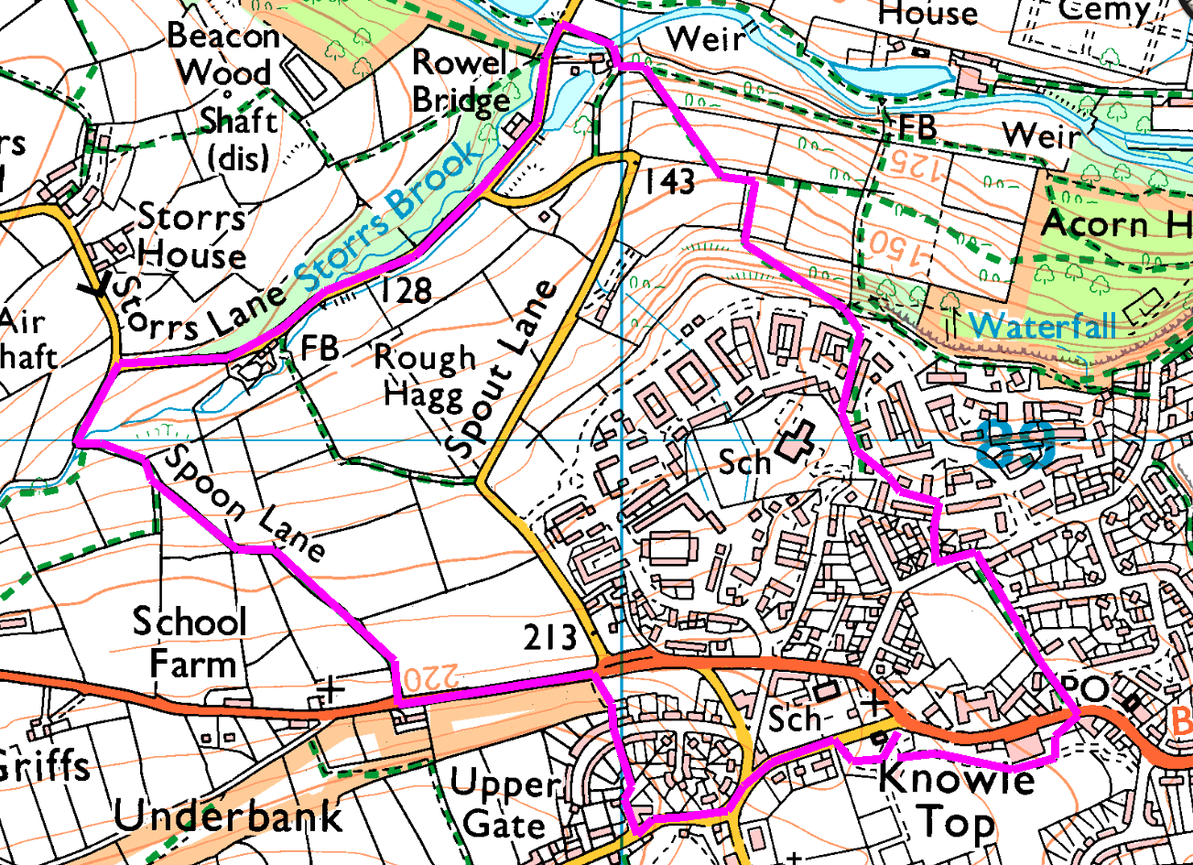
Clockwise
We start at the library beside Stannington Park, turn left up Uppergate Road, bear right and pass the pub then turn right along the footpath which drops down some steep steps to Stannington Road
Turn left to the chapel then right down Spoon Lane (a bridleway). At the other end turn right down Storrs Lane and pass Stoneface (we will have 5 minutes for you to look round). At the bottom, cross the bridge then turn right along the footpath and cross back over the other bridge and up the steps. Head diagonally uphill between the paddocks and through the trees to Acorn Drive. Go up Oak Apple Walk and round beside the school. Just before the school gates, turn left to emerge on Scarlett Oak Meadow. Walk down and turn right, up the other branch of the road, then left between the houses and right up the path to Greaves Close. At the end of the close, turn left, cross Greaves Lane and turn right to find the footpath through to Pond Road. Cross Stannington Road and head across the car park back into the park and return to the minibus.
Risks
- Steep slopes and several sets of steps, may be slippery if wet.
- 2 major road crossings, walking along country lane with no footpath
- Paths may be muddy or slippery if wet.

