## 49 –Wincobank Fort and Roman Ridge – 2.6 miles

Clockwise

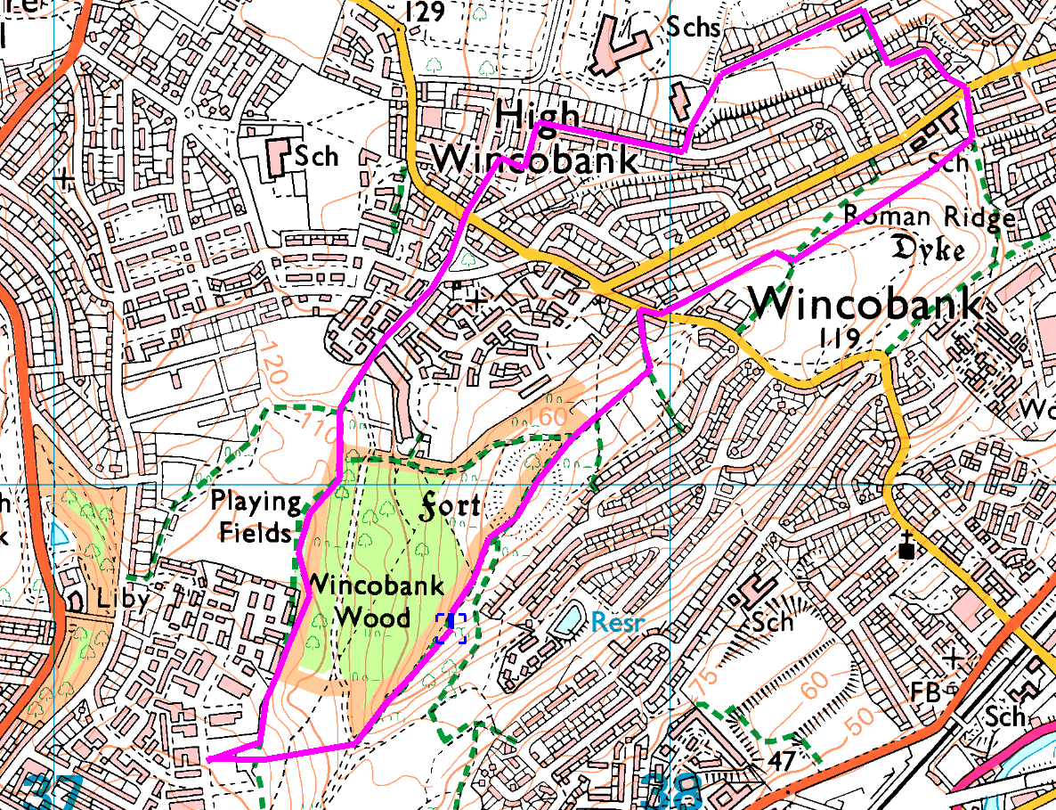A walk up to see the ‘fort’ at Wincobank from the other side

Park on Wensley Street, near Hinde House Crescent. Cross the road and enter Wincobank Common.

Bear left and follow the backs of the houses through to the old playing fields; carry on straight acrossand come out in the ‘Flowers Estate’ on Bluebell Road. Go down to Wincobank Avenue, right and left to Wincobank Road, and cross Shiregreen Lane (carefully).

Take the ginnel straight ahead, cross Tenterden Road and carry on to Leedham Road, turn right to Jepson Road and then left and follow round to the school entrance. Go down the footpath and follow Fife Street to the first blocks of houses on the right. Turn right between the houses and then left onto Barkby Road then cut through to Newman Road. Right and left to Robin Hood Road and out onto Roman Ridge.

Take the first path on the right, back towards the fort and bear right to pass the buildings on your left. On Jenkin Road turn left and cross to get onto the end of the main path over the fort – and just follow it over the top. Going down, cross the crossroads then watch out for the path through the trees on your right which drops steeply down to Wensley Street.

Risks

* Several road crossings without signals, but only 1 busy road which you cross twice.
* Quite steep, with steps in places.
* Potentially muddy in places

Places to pause and ponder

* The view over Meadowhall and towards Sheffield
* The fort, believed to be over 2000 years old

For more information, see pdf at https://web.archive.org/web/20060622192531/http://www.heritagewoodsonline.co.uk/Wincobank.pdf

Shorter Route:

Follow round to the playing fields and out to Bluebell Road. Turn Right on Wincobank Avenue and right again to stay on Wincobank Avenue, then at the end of Hyacinth Close, turn right up the footpath and follow up to the top of the fort. Have a sit down for a while, then take the path on the right which heads downhill. At the end of this path, turn left – this path takes you back to the start.

