Walk 48 – Wantley Dragon– 2.7 miles.
Starting point: End of More Hall Reservoir Road
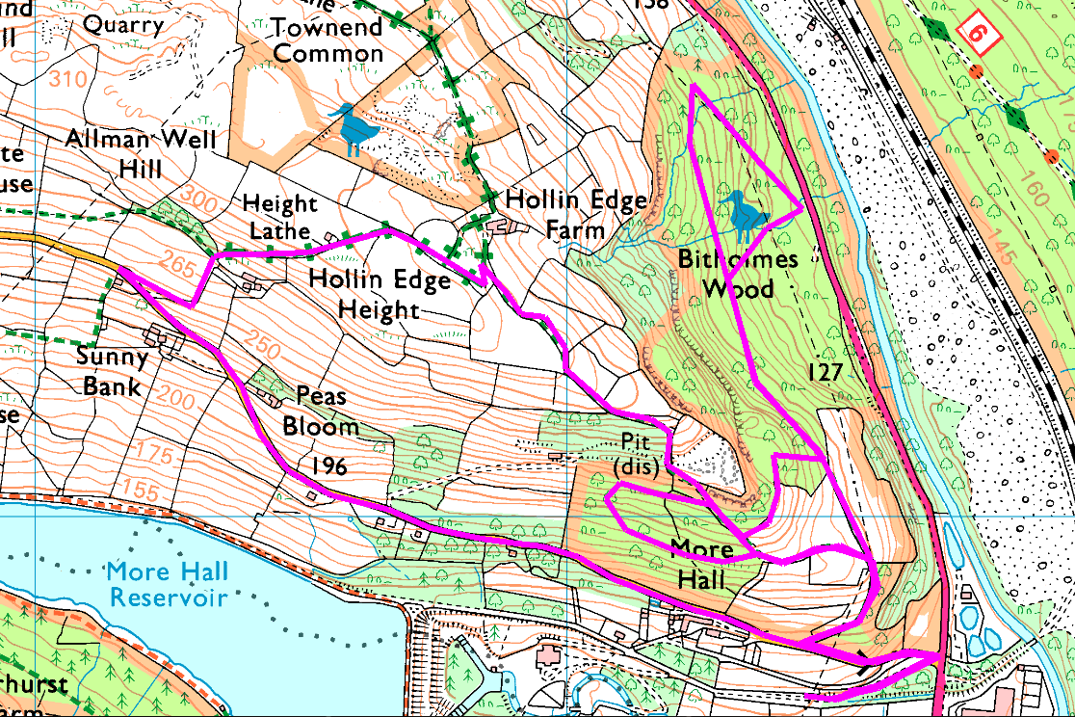
This is an exploratory walk to Bitholmes Wood along woodland paths which the Woodlands Trust describes as ‘steep in places’ and ‘may be muddy’.

If the weather is wet (meaning the footpaths will be slippery), there is an alternative route shown which uses firmer paths and returns down the road.
Both these routes go past the famous Wantley (or Wortley) Dragon, which was reputed to live near Wharncliffe Crags and fly across the valley for his dinner.
The short walk is along the reservoir road, which is level and flat (apart from the speed humps) and not very busy.
Risks:
- Steep slopes, path may be wet and slippery through the woods
- Road crossings and walk along roads

