44 – Stannington Revisited– 2.5 miles.
Starting point: Stannington Library, Uppergate Road, Stannington, Sheffield S6 6BX
Steep climb / steps up. Footpath across field may be muddy.
Essentially the same walk as week 9, just changed a bit.
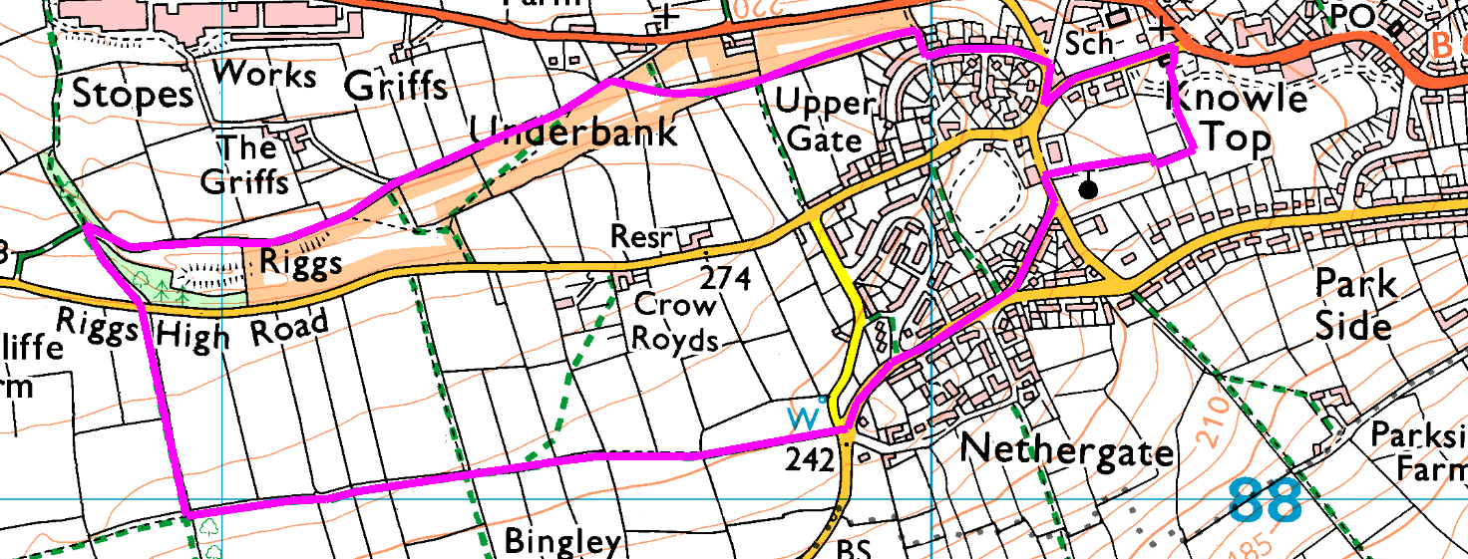

Short Walk: Go out onto the road, turn left and follow the pavement right round the park.

Risks:
- Grassy footpaths (sloping down), mud, stiles
- Road crossings (2 major, several minor) and walk along roads

Places to pause and ponder
- Views over both sides – can you spot Our Cow Molly?

