41 – Ecclesfield North – 2.7 miles

A steady climb to the top of Chapeltown College then a steep dip and climb across Hunshelf Quarry to Hoyle House and back via the Wheel. Shorter options are available.
Park anywhere between the Wheel and the Church (unless you’re using the shortcut in which case park near the church)
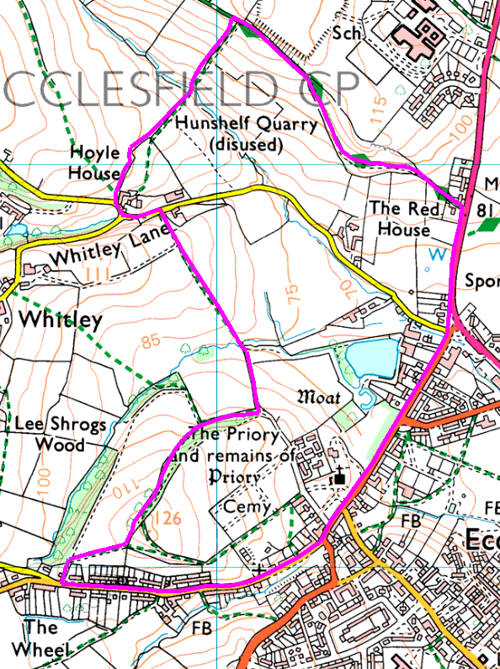
Anticlockwise
The first bit is the hilliest, especially the dip and climb through Hunshelf. Whitley Lane can be used either as a shortcut back or as a way out to avoid the steep and possibly muddy bits.

As you approach the priory, there’s a shortcut back down the road (this was Grahams plan A) but we added on a bit by walking out to the Wheel

Risks
- Traffic on the road crossings, quiet roads.
- Steep descent and climb on main walk

Places to Ponder
The Wheel – probably an old water wheel, but what was it driving? Possibly the answer is further down the road in File Cutters Cottage?

