# 39 – Beeley and Oughtibridge – 2.8 miles

A flat walk out beside the river, then a steep climb up the road before hitting the fields (and a couple of stiles) back across the top of the woods and a choice of paths down through the trees.

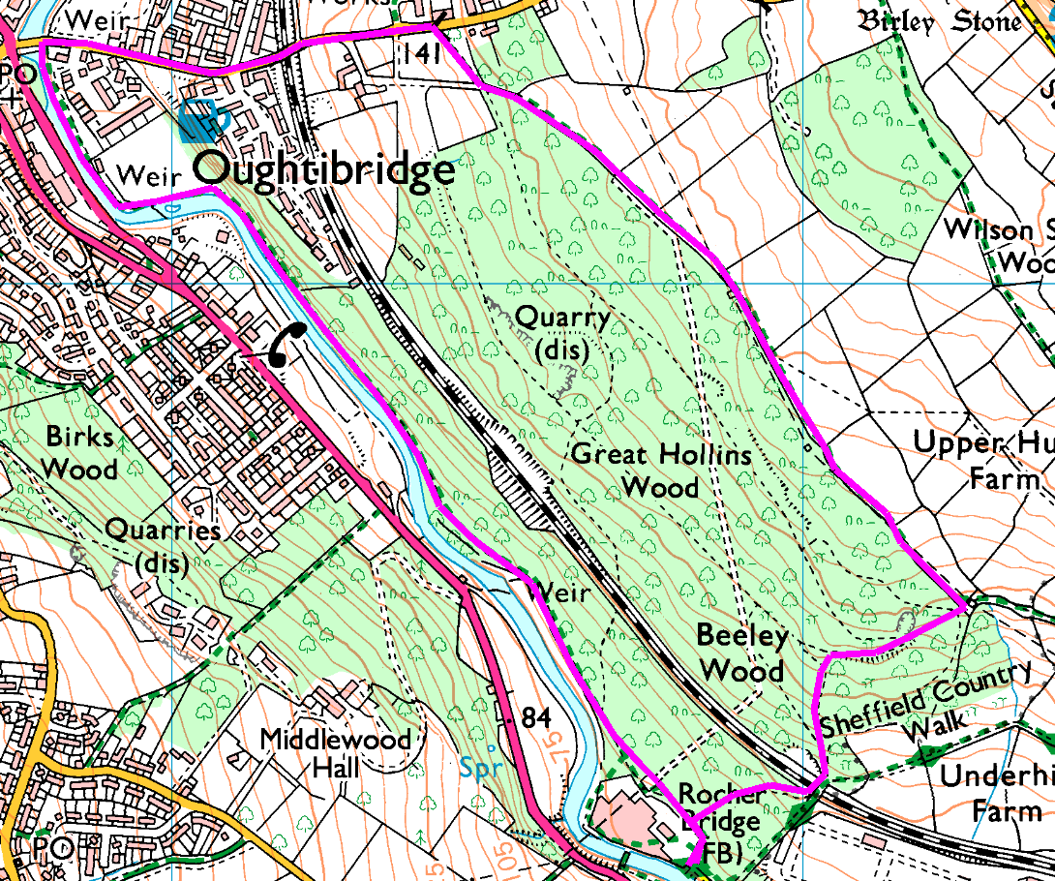Anticlockwise

From the car park, follow the main path … keep following it … (if you want something different, follow the river bank, it’s prettier) … and eventually you get to Oughtibridge!

Go out onto the main road and turn right, up the hill, out of Oughtibridge. Cross the railway bridge very carefully and carry on till the second track on the right (look for a footpath sign).

The track bears left and follows the wall round the ouside of the wood, crossing half a dozen fields in the process. Eventually the path bears left away from the wood – at this point turn right through the gate into the wood and follow the left hand track. Turn left and descend steeply to the footbridge over the railway, then (depemding on the weather) either take the steep scramlbe down on the right or straight down the smelly steps straight ahead, to return to the road.

Risks

* A couple of steep descents which may be slippery if wet. Avoid these by going further along the track through the wood and down to the level crossing over the railway (adds about half a mile!)
* Take extreme car on the road over the railway bridge and up the next hundred yards – it is very narrow and quite busy.
* Tree roots, etc.; Paths may be muddy or slippery with wet leaves.
* Popular dog walking route (and not all owners are responsible)
* Joggers and occasional cyclists
* No major roads to cross, but watch out for traffic on the side roads

Revised Jan 2022