Walk 31 – Morley Street Allotments – 2.7 miles

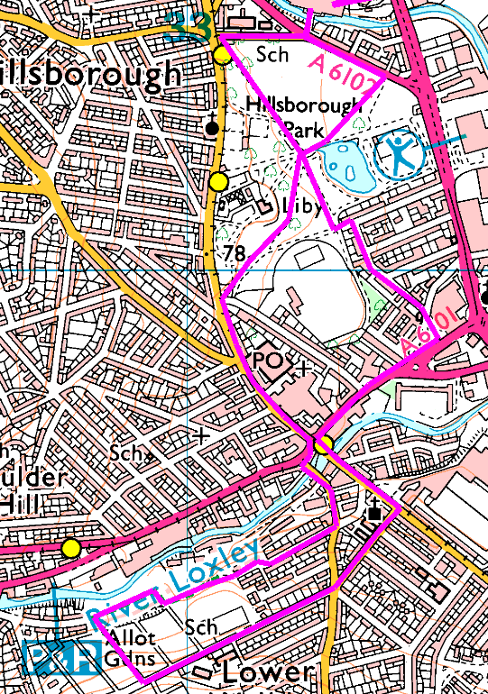
Another different Stadium walk this week, to visit the allotments in Lower Walkley.
Start by walking through the park to the middle of Hillsborough and turn right into Holme Lane then left over the bridge into Walkley Lane. Pass the Riverside pub then right into Limbrick Road. At the end of Limbrick Road, turn left and cut through to Thoresby Road. Turn right and at the end, either through or round the trees to get to Watersmeet Road.
You can take the first or second path on the left off Watersmeet Road, both go straight up to Morley Street where you turn left and head straight back, onto Ripley Street and down to Langsett Road before heading back through the park.

Shorter routes – round the park, up to the crossroads, or Forbes Lane – plenty of choice.

