Walk 30 – Meynell Road

Different walk this week. Start at Meynell Road (no 51) at 12:20 to walk to the Stadium for 13:00, then back the long way round – total 2.7 miles. This will be followed by a Chinese Hot Pot – those people not stopping can return to the Stadium via the direct route (down Penistone Road) or the scenic route through the Binsteds which is about 100 yards longer.
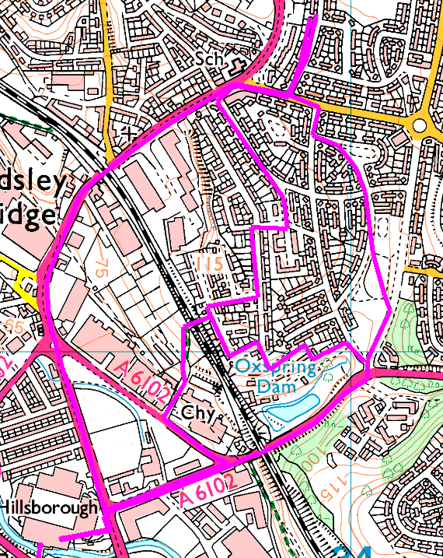
First Leg – down Meynell Road,right and left past the shops, through the Binsteds (Avenue, Grove, Glade, Way) over the railway and down Herres Road.
Second Leg – from the Stadium, up Herres Road, under the arches, left at Wordsworth Ave and across Cookson Park. Right on Halliwell Crescent, right on Cookson Road, left on Southey Green Rd and right up Meynell Road. Those people returning to the Stadium can ignore Meynell Road and turn left to follow leg 1 or straight down Penistone Road.
Short option – up Herres Road, left at Wordsworth Ave then left onto Cookson Road and left again onto Oxspring Bank. Follow path on right to Binstead Grove then left on Binsted Way and left over the railway OR Cookson Road, 4th left to Binsted Drive, 2nd left to Binstead Grove then Glade, Way and over the railway.

Due to the amount of rain we have had recently, we are not putting the tent up so it could be cosy indoors. We have food, tea and coffee and red and rose wine, but if you want beer or white wine, please bring your own. Traditionally we will be drinking Chinese tea (we have a couple of flavours for you to try)
People starting at the stadium and stopping to eat can complete their walk afterwards, or catch the bus from the road end.

