Week 29 – Rivelin and Bole Hill – 1.7 miles.

Short but steep with over 400 foot of climbing and a ‘dead’ steep descent through the graveyard.
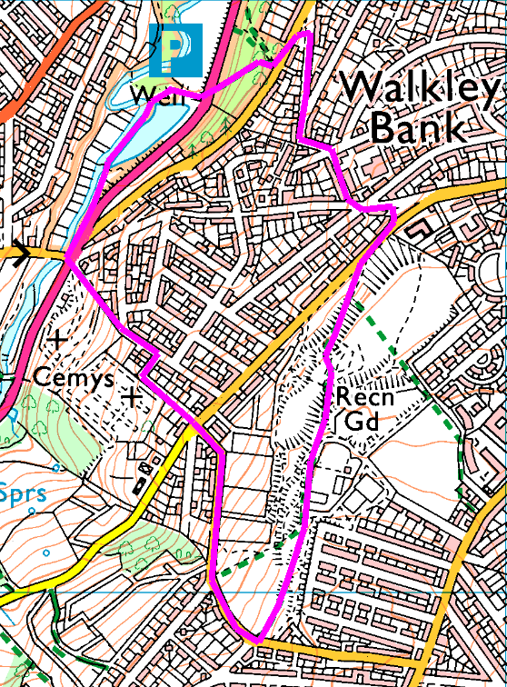
Clockwise
Park in the allotment car park, about half a mile up Rivelin Valley Road (it’s easier to spot the parked cars than the very small sign pointing to it). Cross the road, bearing left and up the path through Walkley Bank Plantation. Cross Walkley Bank Road and head up the jinnel to Fern Road. Turn right and follow round, cross and up Thrush Street. Left on Rivelin Street and right onto Bole Hill Road.
Bear left towards the BMX track, then head straight across the park, stopping to admire the views (Graham should be able to advise the most scenic route), to eventually emerge onto Tinkers Lane.
Turn right and follow down to Bole Hill Road, cross and proceed down the track opposite. At Nichols Road, turn left into the cemetery. Take the third right (just before the left bend) and follow down to St Michaels and eventually back to Rivelin Valley Road.
If the weather is dry, cross the bridge and turn right to follow the river before crossing the stepping stones and back to the bus – OR – turn right before the bridge and find the path between the river and the mill pond, avoiding the stepping stones.
Risks
- Steep hills up and down
- Crossing busy roads.
- Muddy footpaths, steps, tree roots, leaves, etc
- Stepping stones (optional)
Places to pause and ponder
- 'Bole' hills were places where lead smelting was done in olden times and were picked because of the wind 'draught' for bringing fires up to high temperatures.
- The Bole Hills are at the end of Rivelin Valley which funnels the wind making it stronger than it otherwise would be, and gives us an excellent view!

COCKED HAT COTTAGES
Mr Unwin and his family have lived in Cocked Hat Cottages since they were built in approximately 1860. They stand near the junction of Bole Hill Lane and Tinker Lane which years ago used to be called Cocked Hat Lane hence the name of the cottages, although the shape of the land is roughly triangular like the cocked hat that sailors wore.

The gable end facing onto what is now Tinker Lane had a hay loft up above, you can see where it has been bricked up, at the top and there was a stable underneath. The doors have been filled in with matching stone and the stable and hay loft has been converted into a cottage. Mr Unwin believes the small windows at the rear of the property were due to the window tax and there are no windows at all in his lounge. The Unwin family owned a quarry on the Bole hills and Mr Unwins mother used to keep the Punch Bowl’ on Crookes. Dam Flask can be seen quite clearly from the cottages and Bole Hill Lane or ‘Cocked Hat Lane” was an un-surfaced country lane. Hay was grown for the horses to the rear of the cottages on what we would call the Bole Hills and you can still see the change in the vegetation, with the “grass” being much longer and more like stalks.

