## 27 – Firth Park and Wincobank Fort – 2.4 miles

Anticlockwise

A walk up to see the ‘fort’ at Wincobank

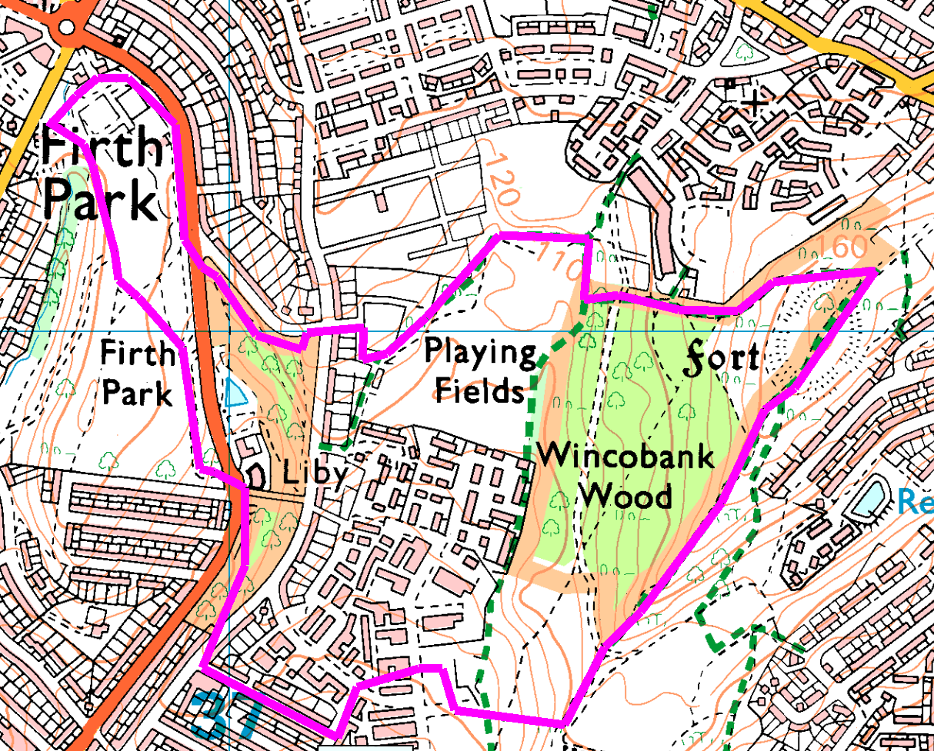Starting from Firth Park car park, head through the park to the far (South Eastern) corner and carefully cross the road. Ahead there are steps up, but just to the right is a path through the trees, which brings you out onto Hinde House Lane.

Cross over and turn right, then left into Willoughby St. Walk down to the end before turning left and following the path to Hinde House Crescent. Cross over and take the path through the houses, bearing right. Cross the road and enter Wincobank Common.

Bear right towards the concrete area, then take the path through the trees which leads uphill to the top of the ridge. Turn left on the track along Roman Ridge and follow through to the far side of the fort. Take a sharp left onto the path which follows the boundary of the wood, turning right and then left round the playing fields (a patch of grass with no obvious pitches or goals). At the back of the houses, turn right and then left between the houses. Cross the road and start down Firth Park Avenue before entering the woods on the left and follow the footpath parrallel to the road. Cross into Firth Park proper and return to the car park.

Risks

* Several road crossings without signals, but only 1 busy road.
* Quite steep, with steps in places.
* Fly tipping

Places to pause and ponder

* Firth Park, Sheffields oldest public park
* The view over Meadowhall
* The fort, believed to be over 2000 years old

For more information, see pdf at https://web.archive.org/web/20060622192531/http://www.heritagewoodsonline.co.uk/Wincobank.pdf

