25 – Beeley Woods – 2.5 miles

Beeley woods can be wet and slippery, so this is not suitable if the weather is very wet or icy. The walk to Underhill Farm is quite muddy. The climb from the car park to the railway is steep, and the factory to the south is noisy and smelly (it handles ash from the waste incinerator).
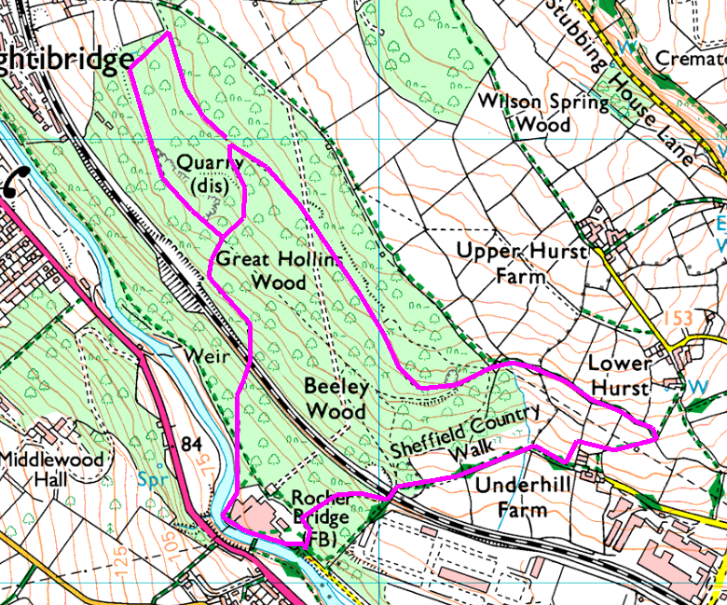
Anticlockwise
From the car park, follow the main path till the first gate on the right, then cut up through the woods following the path and the scramble to the top (alternatively, head down the road to the footpath sign then go up the hill, climbing the steps which are steep and may be slippery). Cross the railway bridge and bear right to leave the wood at the corner. Follow the path across the field (there is a stream here which may be muddy), and go up between the fences till you approach the farm. Follow the path up the hill round the farm, then at the far corner head diagonally across the field to a stile. Turn left and cross another stile into the green lane, and follow this back to the woods. Reenter the wood and follow the trail as it goes round the side of the hill.
Go under the pylons and then watch out for a small gap in the bank on the left – this drops to a path which takes you down the hill, but is a bit steep at the top. Alternatively, keep going along the trail till you see a field wall on the left; just before this turn sharp left and follow the lower trail back. At the crossing, turn right to drop down to cross the railway line and descend back to the start.

