Tongue Gutter – up to 2.3 miles.
Just to show how green Parson Cross is, this walk is fairly flat and on firm surfaces or grass throughout. Overall 2.3 miles, this should be no trouble for the better walkers and there are plenty of shortcuts – including the trivial option of once round the playing fields. Start in the car park at Parson Cross Park.
Best walked in spring when the wild bulbs are at their best.
Anticlockwise
No refreshments, toilets may be open (or start / end at Asda for toilets / café, extra half mile)
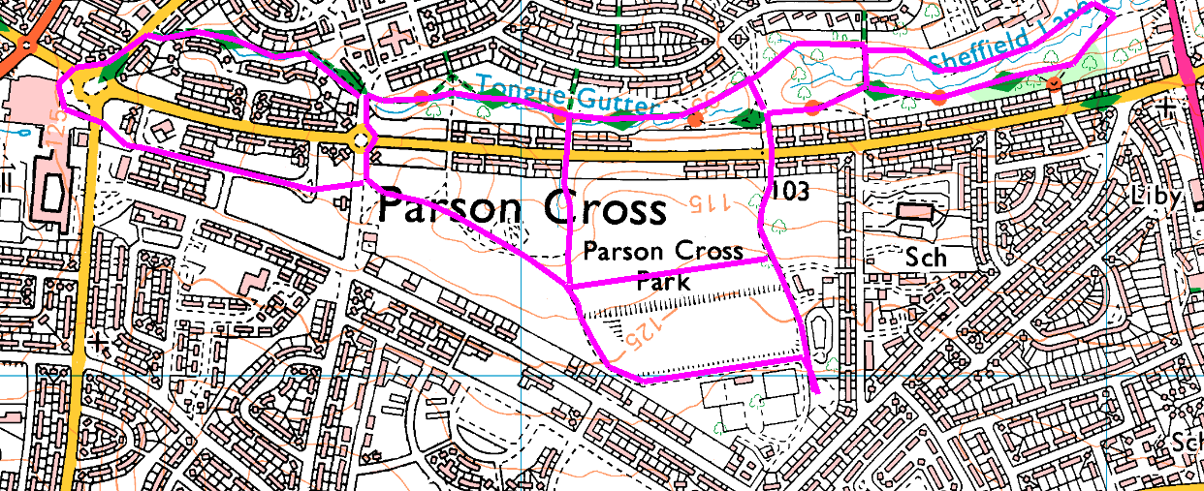From the car park head North, along the path beside the football pitches. (There is a small detour on the right which has a sculpture and semi-wild flowers, including purple crocus in spring.)
OR From Asda, cross Wordworth Ave and the Farmfoods car park, then straight ahead to the park. Cut across the grass beside the pitches then turn left to join the walk.
Continue past the allotments to emerge onto Deerlands Avenue; cross this and continue downhill for a hundred yards before turning right on the footpath. Follow the footpath as far as the second bridge – when the asphalt path bears right towards the road, take the gravel path on the left. If you go too far, you reach the culvert under Barnsley Road and will have to turn back.
Cross the stream and turn left; follow this path back, crossing the first road and continuing to the second road (Holgate Avenue). If returning to Asda, cross this road and follow the stream to the next road; turn left and cross the roundabout back to Asda; otherwise, turn left on Holgate Avenue, straight around the roundabout, then turn left into the Park, bearing uphill to return to the car park.
Options: Any of the paths you see on the left will make a shorter walk, allowing you to cross the stream and return to the park faster.
Risks
- 3 quiet road crossings. (+ 2 busy roads to Asda)
- Walking beside the stream – it is shallow but may be polluted by storm overflow and cowboy builders.
- Usual problems of footpaths – cyclists (rare), dog muck, mud, litter. This is part of the TPT, but rarely used.
Places to pause and ponder
- Best views are as you start, over towards Grenoside.
- A piece of countryside in S5 – few people even know it exists.
Crocuses, snowdrops, narcissi and primroses, plus vivid bark of dogwood in spring.

