23 – Bradfield – up to 2.5 miles
Start at The Sands car park, Bradfield
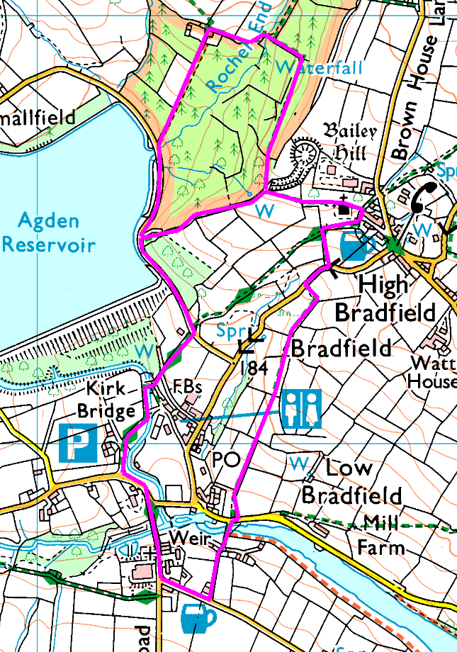
Please note there is no mobile phone coverage in this area, especially in the valley.
Anticlockwise
This walk has a steep ascent over the fields with a couple of stiles, a short stop at the church to admire the view (and see if the fallen tree has been removed), then a steep descent through the woods and a gentle stroll along the road to finish (except for the steps down – 80 of them!)

Risks:
- Quiet country roads to cross / walk along
- Footpaths – dogs, tree roots, etc.
- Mud, wet leaves, slippery if wet.
- Steep drop beside path – take care.
Places to pause and ponder
- The church – great views and an interesting building.
- The old Motte and Bailey castle, hidden in the trees

If that sounds a bit much, here’s an alternative – 1.8 miles, still has the 80 steps at the end (but we can skip that bit, if you want)
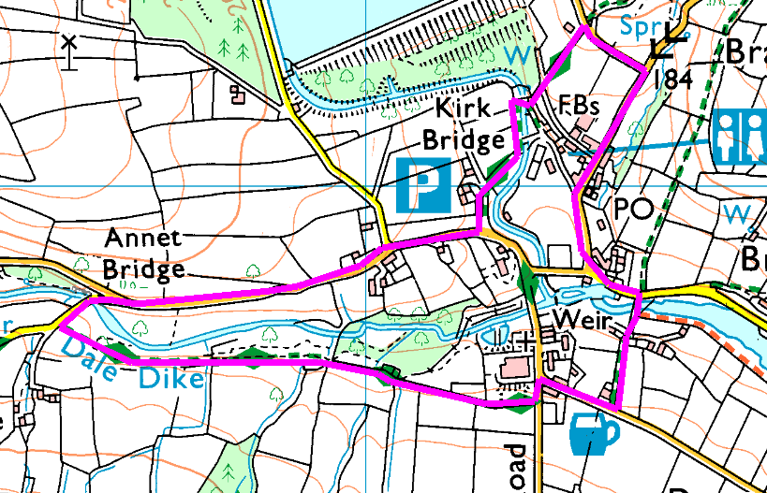
This is a completely separate walk, so let us know at the start if you want to do it.
Anticlockwise

From the car park, turn right on the road and follow to Annet Bridge (first left). Cross the bridge and after a few yards take the footpath on the left (the gate may open, but is heavy, otherwise the stile has quite a high step). Follow this footpath over 2 more stiles and a water channel to pass the community orchard and the old water works. At the end of the track, turn left and follow the road back to the car park.
Or, at the road turn left and then right, past the pub and then left along the track and over the bridge. At the road, turn left then bear right and (*) right again (up the hill). Take the first left then turn left down the narrow path and the steps to return to the car park.
Avoid the steps by bearing (*) left, past the toilets and round to the car park on the level.

Risks:
- Quiet country roads to cross / walk along
- Footpaths – dogs, tree roots, etc.
- Mud, wet leaves, slippery if wet.
- Stiles
Places to pause and ponder
- The bridge – see how much water is in the reservoir.
- The community orchard (a bit bare at this time of year)
- Annet Bridge – was washed away when the dam burst in 1864

