22 – Loxley and Stannington – 1.65 miles (updated to 2.5 miles)

Another hilly walk with a steep uphill through the trees and a steep grassy downhill. The first third is very flat, beside the river, so suitable for an easy out and back walk. There is also an option to cut off the top of the hill (the original walk) but nobody wanted to do it!
START AT Rowell Bridge. Park in the layby beside the bridge.
Clockwise
From the layby, follow the easy walking trail downstream, past the millpond bearing right when the road heads uphill to pass between the houses. Either go down the steps on the right or take the sharp right just after, and cross the footbridges over the mill tail and the river.
For the easy walk, turn back here (if you have time you can walk a bit further downstream before turning back). The main walk goes uphill through the trees.
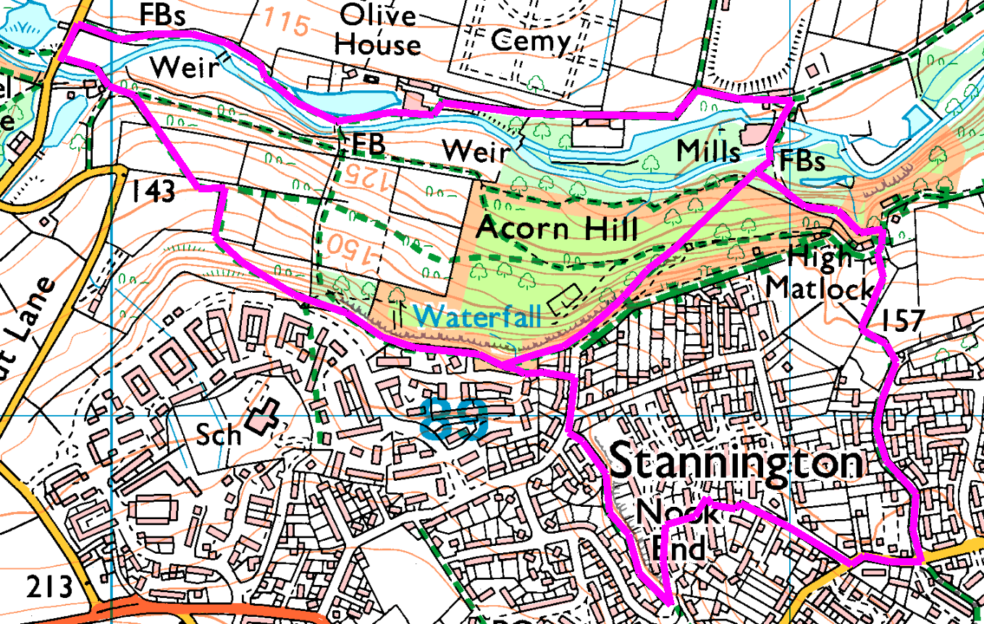
For the shorter walk, bear right (up the muddy bit) and straight up the hill. The first part of this path is not too steep, but after the crossroads it becomes a bit of a scramble. For a gentler climb, turn left at the crossroads and head towards the old Robin Hood, then right up the old road to rejoin the walk at the top of the hill. Skirt the edge of Stannington before rejoining the main walk.
For the longer option, after the bridges take the left hand, paved path with a hand-rail. Follow up to the old Robin Hood then take the footpath opposite the front of the building which takes you up to Myers Grove Lane. Turn right and follow Myers Grove Lane to the end, then turn right into Wood Lane. Turn right into High Matlock Road and straight on where the road splits. At the end, turn left into the jinnel, straight across Little Matlock Gardens and left on High Matlock Avenue – basically, uphill all the way!
Before the road bends right, go up the steps and follow the footpath behind (and above) High Matlock Avenue. This is the highest part of the walk, and the views are spectacular so take a few moments to rest and try to spot the stadium.
We are now heading straight bacck to the bus, and while it’s not quite downhill all the way, it’s not far off.
At the end of the footpath turn right onto Greaves Lane. Look out for a narrow opening on the left, or if you miss this, turn left at the end of the houses. This puts us on the route of the short walk, so the rest of the route is shared.
Follow through the trees along the top of the cliff (actually it is a quarry with an old shooting range at the bottom) till you emerge onto Acorn Drive. Walk round the end of the fence and down the paved path known as Acorn Hill – this is steep and probably slippy in wet weather, so take your time and stop to admire the view. This path takes us over a couple of stiles and down some steps, then back to Rowell Bridge and the car park.

Risks
- No major road crossings, but beware of traffic in Stannington on the narrow streets.
- Water – riverside and footbridges
- Steps (most can be avoided) and some rough paths
- Cyclists and dogs.
- Getting lost in Stannington!
Places to pause and ponder
- Mills and millponds – this part of the river is quite agricultural.
- Acorn Wood – mines and quarries
- The pub without beer
- Views from the top.

