21 – Greno Woods – 2.0 miles

A blue walk this week (must be cold), almost completely through the trees. Quite hilly but mainly good underfoot.
START AT Greno wood car park, Woodhead Road, S35 8RS
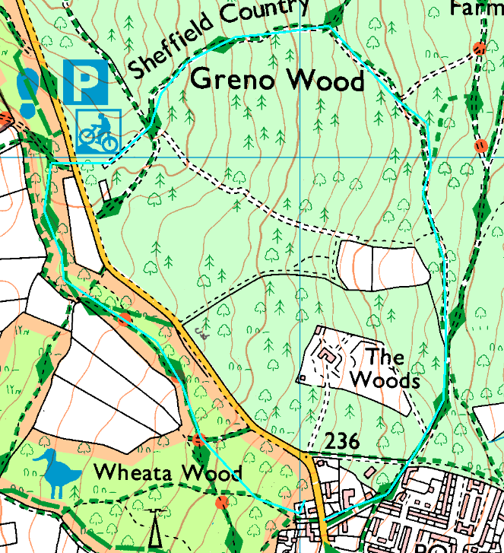
Clockwise
Difficult to describe this route, but it’s more difficult to get lost. From the start, cross the road (carefully) and follow the path. After a steep descent, cross the junction and bear left down the hill. Follow the path right and straight on to the pub.
From the pub, cross the road (carefully) and head up the footpath between the houses. In the wood, bear right onto the well-used trail which leads up to the car park.

Risks:
- 2 country roads (can be busy)
- Footpaths and bridlepaths – horses, dogs, cycles (although they have their own routes), tree roots, etc.
- Mud, wet leaves, slippery if wet.

Places to pause and ponder
- Watch out for the willow pit, used to soak willow for basketry
- The pub – just let us know if you are stopping there!

