20 – Parson Cross (almost) – 2.6 miles

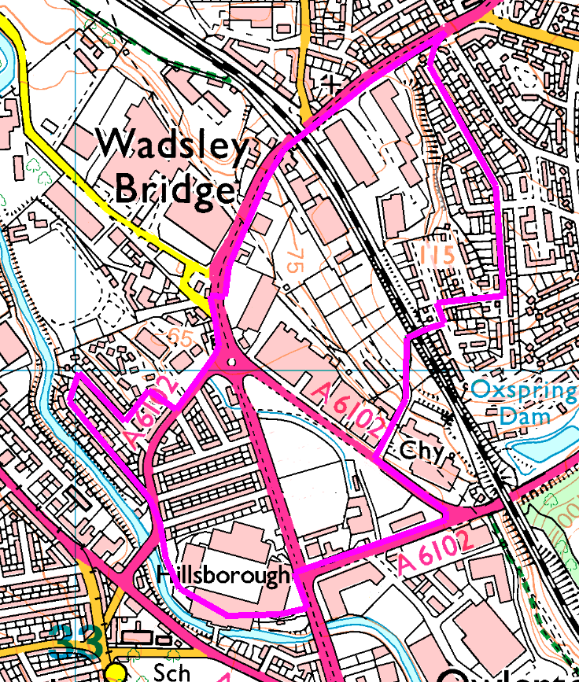
Clockwise
A road walk, to make up for all the mud last month!
From the stadium, head to Leppings Lane and have a short diversion along Shenstone Road, Eskdale Road and Eskdale Close to emerge besides Hillsborough Dairy. Head behind the Spar and Burger King before crossing Penistone Road near Carphone Warehouse. Head up past the gym, under the bridge and over Kilner Way to Avisford Road.
Double back across the car park, down the jinnel to Binstead Ave and follow it to its end, crossing Binsted Crescent straight into Binstead Grove. When you reach it, turn right into Binsted Glade and then left into Binsted Way, passing Binsted Croft. Watch out for the footpath on the right – if you get to Binsted Gardens you’ve gone too far (somebody had very little imagination naming these streets!)
We’ve been over this bridge before – just follow your nose back to the stadium.
Risks
- Usual road crossings – Leppings Lane, Penistone Road (twice) and Herres Road, plus side roads
- Steep descent
- Fly tipping
Places to pause and ponder
- Look at the different house styles and periods.
- Herries Road – the old brewery and Wardsend Mill
- Views from the top.

