19 – More Hall reservoir – 2.5 miles

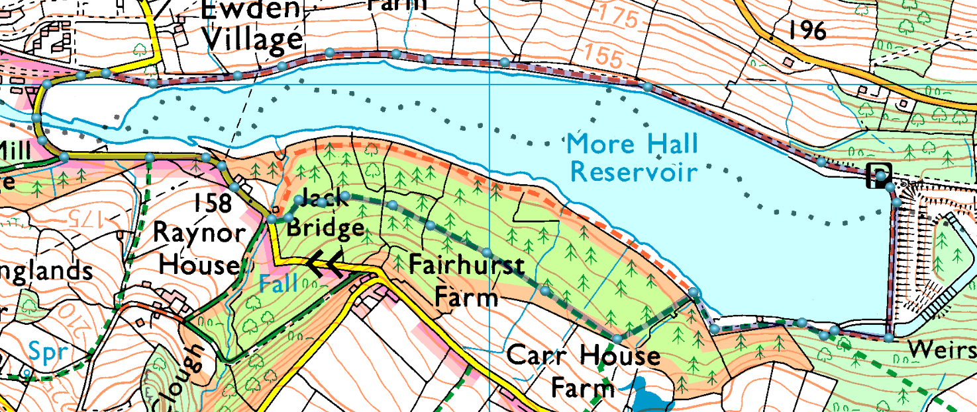
An easy walk round the reservoir, with an optional climb up the road and back down through the forest, or for the less adventurous, a gentle stroll back along the banks and over the dam.
Park north end of the dam, follow the (private) road to Ewden then turn left and follow round over the bridge.Go through the gate on your left to follow the permissive path all the way along the south bank back to the dam for a gentle stroll, or:
Follow the road up the hillto Jack Bridge then enter the forest and follow the trail round and back to the easy route.
Or follow the water till you see a path going uphill on the right, then join the trail back down.
Or… There are a couple of paths going round Raynor House which are quite steep and challenging (if you fancy a change)
Risks:
- Finding the reservoir (quite difficult if you have never been before!)
- Road walking (very quiet roads)
- Forest path (well maintained)

