18 – Rivelin West End – 2.3 miles

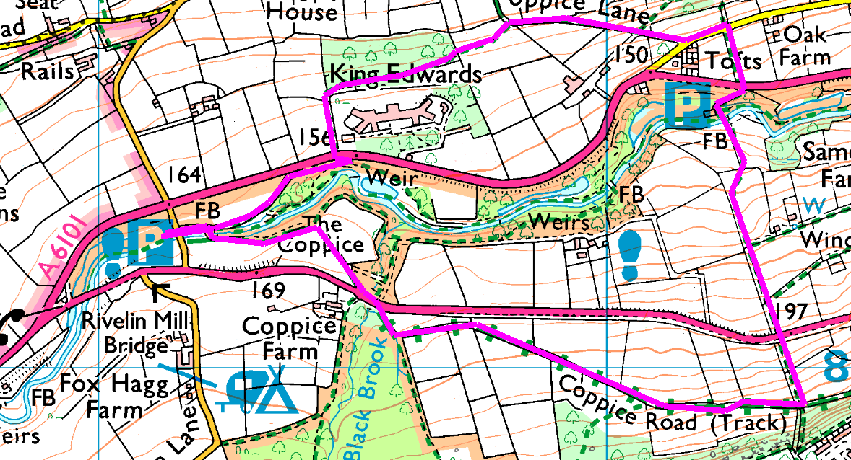
From the car park, cross the road and follow down the stream before crossing the bridge. Head up the path to the road, cross with care and head up Coppice Road for half a mile. Go down the stile / steps on your left and another 6 stiles (some with steps) crossing back over the road and eventually arriving at the river. Cross the bridge. If you are tired, turn left and follow the stream back; otherwise go straight ahead up the steep, cobbled, slippery slope. Cross the road and straight across the stile into the field; follow up the fence till you reach the road and turn left to follow it for a hundred yards, before bearing right up Coppice Lane.
Where the lane bends right, go over the stile on the left and follow the footpath into the wood (muddy). As you emerge from the wood cross 2 stiles (one with holly) and drop down to the road. Turn right and follow the road for 30 yards before crossing and taking the track through the trees back to the car park.
Risks
- 4 major road crossings. Short walk on quiet road
- Lots of stiles (10 or 11), some dodgy steps and some rough paths
- Possibly muddy / slippery, depending on the weather
Places to pause and ponder
- Nice views
- King Edward 7 orthopaedic hospital

Possibly the best walk so far – but slow due to number of walkers and number of stiles.

