17–Tongue Gutter – 2.4 miles

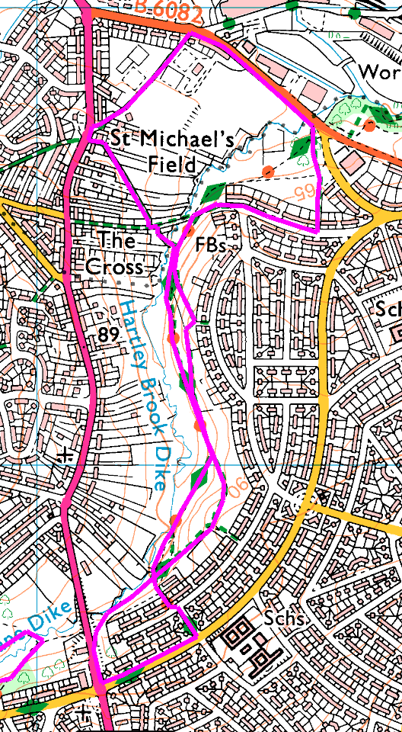
There are many small streams round Sheffield, and today’s walk follows one of them. Called Tongue Gutter at the top, this stream is also called Sheffield Lane Dike and the part we are walking beside is Hartley Brook. The path we are following is part of the Trans Pennine Trail, so it is fairly well maintained but may be wet, depending on the weather.
Clockwise(ish)
Park at the side of Butterthwaite Road (S5 0AT) and walk to the end, then onto the footpath. Take the first left (part way down the hill) and follow along the path to the culvert under Barnsley Road, where there is a set of steps up to join the road. Turn left and left again at the traffic lights, then left again just before the school. Cross the road at the bottom and re-join the TPT.
We are now retracing our steps along the dike, but there are 2 paths for most of the way – so whichever path you took coming, take the other one going back. The upper path has more snowdrops and daffodils, the lower path is more level!
As you approach the end, watch out for a footbridge and a path through the allotments – and the black pigs. Go straight on at the crosspaths and up to the main road. Turn right and almost immediately right again and take the footpath past the sports club. On Green Lane turn right and follow round past the sports pitches.
Just before Sicey Ave, take the footpath on the right then bear left and follow back to Butterthwaite Road and the bus.

Risks
- No road crossings. Quiet street walking, plus a couple of major roads
- Steps (can be avoided) and some rough paths
- Cyclists – never seen any, but just in case – and dogs (plenty of these).
- Farmyard smells – can be avoided but gives a shorter walk
Places to pause and ponder
- The culvert. One of these days, you may see the other end of it.
- Flowers – snowdrops and crocuses, maybe daffodils as well
- Pigs

Crocuses were very early this year, so just right timing.

