16a – Club Mill Road – 2.5 miles

The full length of Club Mill Road, down to Hillfoot Bridge is too long for a health walk (and the bottom end is a bit boring), but this route explores some of Wardsend Cemetry below the railway and the old spoil heap beyond before returning along Club Mill Road.
This route is the reverse of walk 16, climbing the gentle slope to the spoil heap and the great views while avoiding (most of) the mud. I’m being lazy and using the same map.
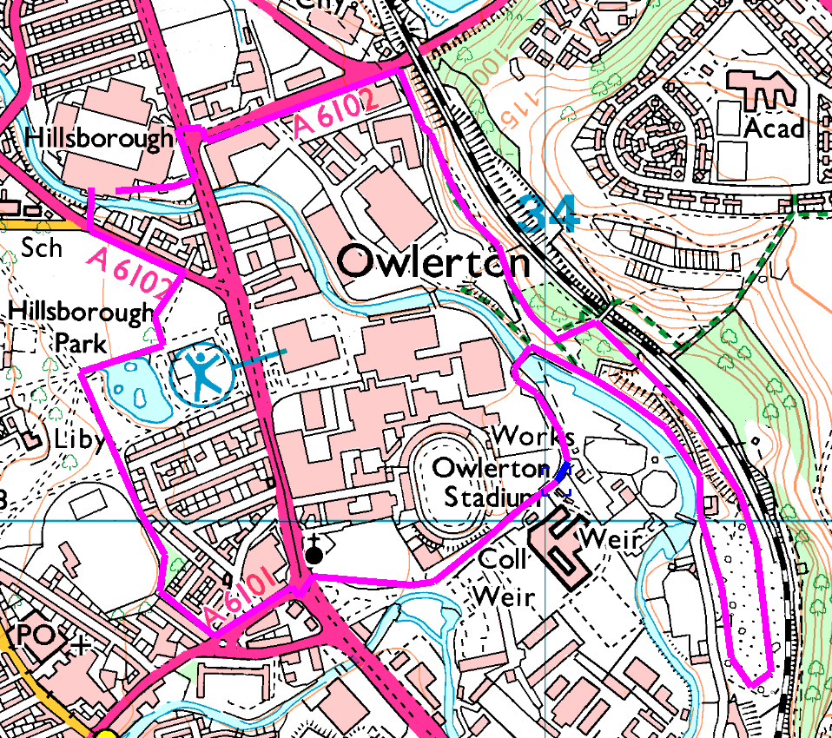
Anticlockwise
Out of the stadium and through the park (we actually went by the top path and down Hawksley Road) to Bradfield Road and Livesey Street (mind that crossing). Follow round and over the blue bridge, then turn right along Club Mill Road beside the river.
Where the wider track bears left (uphill), follow it. You can scramble up one of the steep slopes on the left or follow the track to the top, to admire the fantastic views before turning back, down to Club Mill Road and back towards the blue bridge.
Watch out for the path on the right which goes past the chapel. Here you have a choice, back the way you came or straight on to Herres Road (through the mud and over the dodgy footbridge).
Risks
- 2 busy / complex road crossings
- Mind the path beside the stream – quite narrow in places.
- Usual risks from dogs, cyclists, etc.
- Very steep banks, both up and down (can be avoided)
Places to pause and ponder
- The spoil heap does give some good views (when you get there).
- Allow time to study the crossing at Owlerton – or you may get lost…

