16 – Club Mill Road – 2.5 miles

The full length of Club Mill Road, down to Hillfoot Bridge is too long for a health walk (and the bottom end is a bit boring), but this route explores some of Wardsend Cemetry below the railway and the old spoil heap beyond before returning along Club Mill Road.
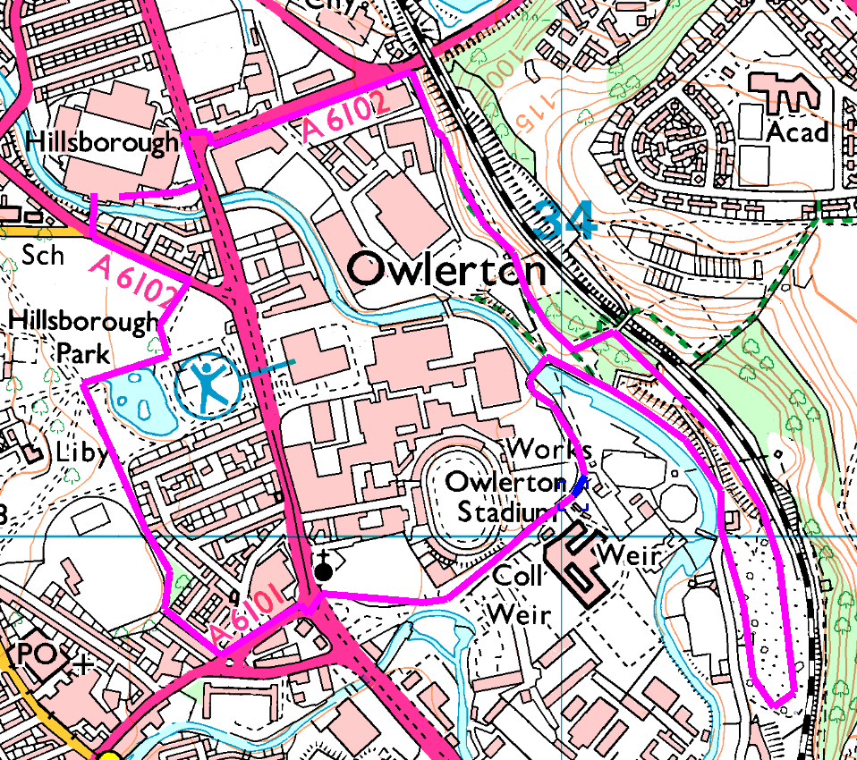
Clockwise
Up Herres road to the culvert, turn right onto the footpath (mind the stream) and follow through to Wardsend Cemetry. Turn left up to the railway bridge, but take the right fork before the bridge. This path goes through the cemety and emerges at the top of a spoil heap, which it follows until it loops round and drops down to Club Mill Road (there are a couple of shortcuts, but the main path has a gentler slope).
Once on Club Mill Road, return to the blue bridge and round through Owlerton to the stadium. The route shown avoids following Penistone Road, but this is a (shorter but more polluted) option.
Risks
- 2 busy / complex road crossings
- Mind the path beside the stream – quite narrow in places.
- Usual risks from dogs, cyclists, etc.
- Very steep banks, both up and down
- Very wet and muddy
Places to pause and ponder
- The spoil heap does give some good views (when you get there).
- Allow time to study the crossing at Owlerton – or you may get lost…

Could not complete this walk due to mud – may try again in summer

