15 – Parkwood Springs– 1.8 to 2.5 miles
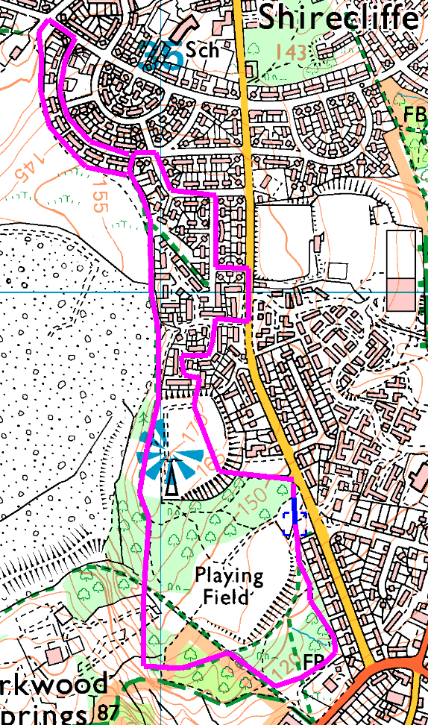
This walk takes in the perimeter of Parkwood Springs, and has some steep climbs and descents (which can be avoided); there are several shorter, flatter options. Start in the car park (if it is open) or the pull in at the side of Shiremoor Road.
Clockwise
From the pull in, head into the trees and take the first path on the left to drop down to the car park. Take the path on the South side of the car park, follow down behind the houses and round to the right (ignore other paths which lead off to the right). As you approach Rutland Road, turn right and then take the path downhill on the left. Before reaching the ski slopes, turn right and follow the fence round to the viewpoint. Go straight on between the houses and the landfill site, before turning right at some point to pass between the houses onto the road. (there are 6 options, the longest emerging beside the HWRC)
On the road, turn right and follow round till you emerge onto Shirecliffe Road. Turn right and then take the second right into Standish Way. Turn left into Standish Bank and follow to the very end, before taking the path through to the football field.
Either head diagonally across the pitches to a steep descent just right of the houses or head past the wireless mast into the trees and turn left onto a path with a gentler slope. Follow this path back to the road.
Risks
- No road crossings. Quiet street walking
- Steep climbs and descents – can be avoided and all at the start!
- Cyclists – there are cycle routes laid out away from the main paths, but some still use the paths.
- Another football club has its academy up here – be careful not to look at it
Places to pause and ponder
- The viewpoint. Splendid view of SWFC stadium and Hillsborough in general.
- Ski village
- Landfill site, now being recovered, we may be able to walk across it in a few years

