14 – Northern General Hospital – 2.4 miles

A linear walk (because John can take us but not bring us back), from the hospital through Roe Wood and across Shirecliffe to drop down to Wardsend Cemetry. A great walk, spoilt by fly tipping, burnt out cars and mud (frozen underneath but very slippery). Advise using the northern route in winter!
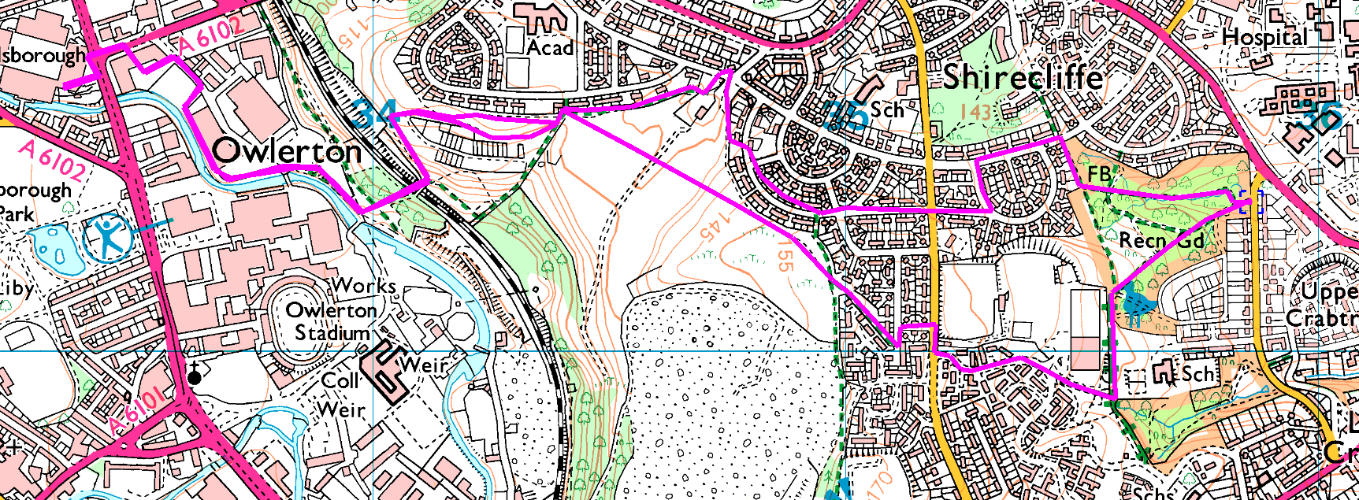
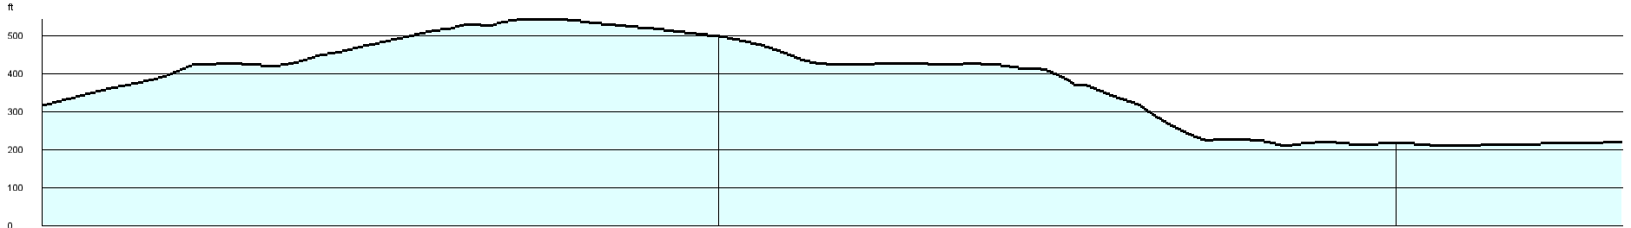
It is downhill (on average) but it does have steps down and a steep slope (dropping down to Wardsend, we usually go up here). It also skirts tho other teams academy ground – sorry.
This is a bit exploratory, as I have never walked through Roe Wood but the path is well used and easy to follow. Across Shirecliffe, there are several paths but we can see where we are going.

