13 – Brick Works Orchard – 2.5 miles

Lots of options for this walk which starts at Concord Leisure Centre and visits High Wincobank and Pismire Hill. Various parts of this walk cross playing fields (which may be wet) and one part cuts through a wood – but all these can be avoided if it is really wet underfoot.
Starting point: Concord Leisure Centre, Shiregreen Ln, Sheffield S5 6AE
Clockwise
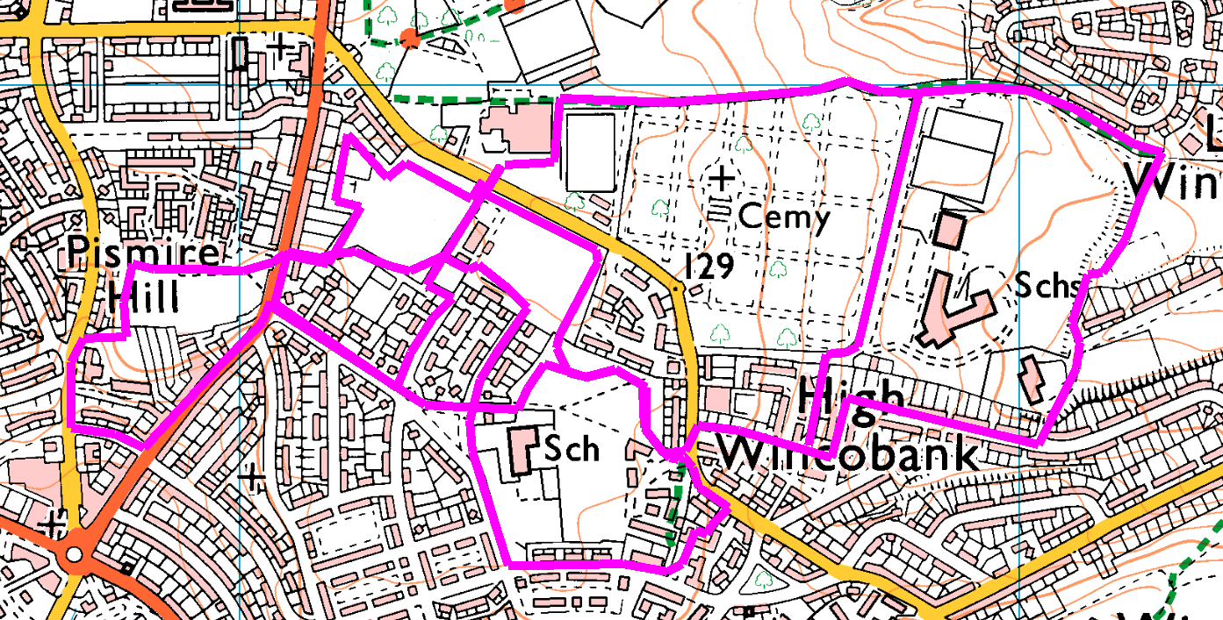
From the car park, go round the far end of the sports centre and take the footpath between the golf course and the cemetry. If Wet: turn right at the end of the cemetry and follow through to cross the school drive and between the houses to turn right on Leedham Road. If Dry: go straight on, through the squeeze and down to the grass. Turn right and head for the far right corner. Take the right hand path into the trees and follow between the houses and the school, to emerge on Fife Street. Go straight on along the path to Jepson Road and turn right. Follow left, then turn right into Leedham Road.
At the top of Leedham Road, turn left on Shiregreen Lane. Cross with care and enter the Brick Works. If dry, keep right to the roundel (shortcut – turn right and cross the football fields back to the car park). Bear left through the orchard to the jinnel. If wet, cross the tarmac path to the orchard and the jinnel.
(optional extension; go down Shiregreen Lane to the path between the houses. Follow this to Wincobank Avenue and turn right. Note the blocks of houses on the right, which are a mix of old and new build. The path between the 2nd and 3rd block leads to the Brick Works, for a shortcut or turn right up Bracken Road and on to Primrose Avenue.)
Go straight on to Acacia Road and Primrose Avenue (shortcut for wet weather – go up Foxglove Road and past the bowling green to the car park) At the end of Primrose Avenue, if dry turn left on Bellhouse Road. (shortcuts or if wet – either turn right up Bellhouse Road to the jinnel, or cross and walk round Pavillion Park).
Walk down Bellhouse Road, around North Quadrant and back up Sicey Avenue before turning right up the hill (steep slope) and crossing the grass into Pavillion Park. Head to the far corner (turn right is slightly shorter than left, but straight across is shortest). Cross Bellhouse Road and follow the jinnel through to the playing fields. Go round the field (or cross) to Shiregreen Lane and the car park.

