Walk 12 – Broomhead reservoir – 2.8 miles Flat but muddy
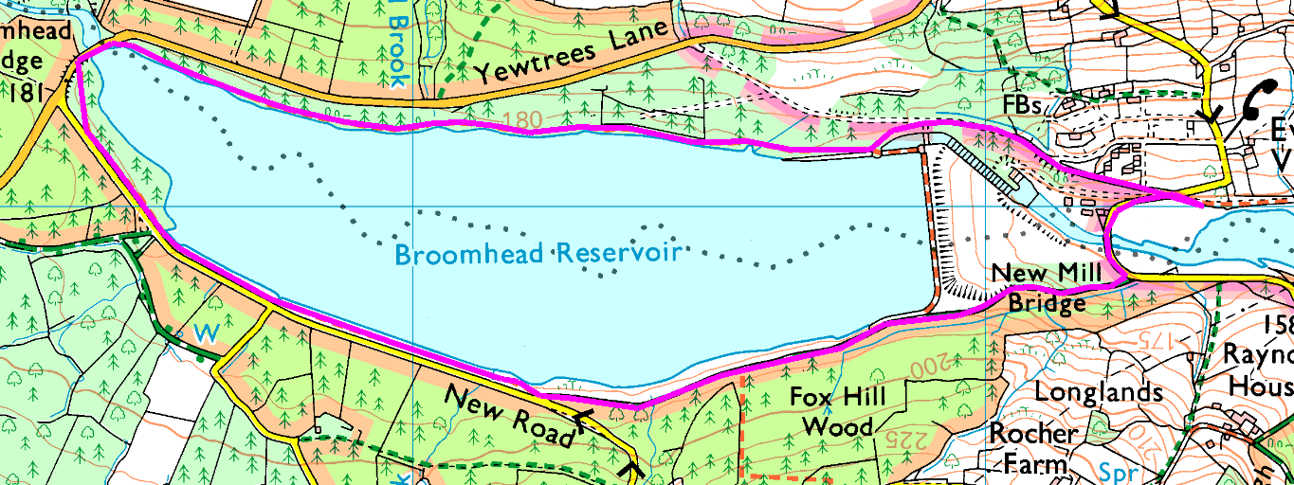
Park at the West end of More Hall reservoir.
Clockwise:
Follow the road round the end of More Hall reservoir then turn right up the footpath. Climb to the dam top, the follow the path through to New Road. As you join the road, take the footpath on your right which follows the waterline till it emerges onto the road by Broomhead Bridge. Cross the bridge and rejoin the footpath, which you can follow right back to the dam.
Bear left and follow the road back to the minibus.

Anticlockwise:
At the crossroads, go straight ahead uphill, past the houses to the dam. Follow the path beside the water till you reach Broomhead Bridge. Cross the bridge and rejoin the footpath, which you can follow till it emerges onto New Road. As you join the road, take the footpath on your left which drops down past the dam to the road near New Mill Bridge. Cross the bridge and return to the minibus.

Risks:
- Broomhead Bridge – traffic can be moving fast, and there is no pavement.
- Water – in places you are very close to the water (it may flood over the path on the North side).
- Mud – even in summer.
- Tree Roots and uneven surfaces
See route 66 for a longer, harder walk (3.2 miles)

