11 - The two sides of Middlewood – 2.8 miles from the stadium, 2.0 miles from the training ground

Middlewood consists of 2 estates, Wynn Gardens and Middlewood Drive, which are very different in nature. This walk visits them both. Unfortunately there is a long busy road to walk beside there and back, unless you take your car to the training ground.
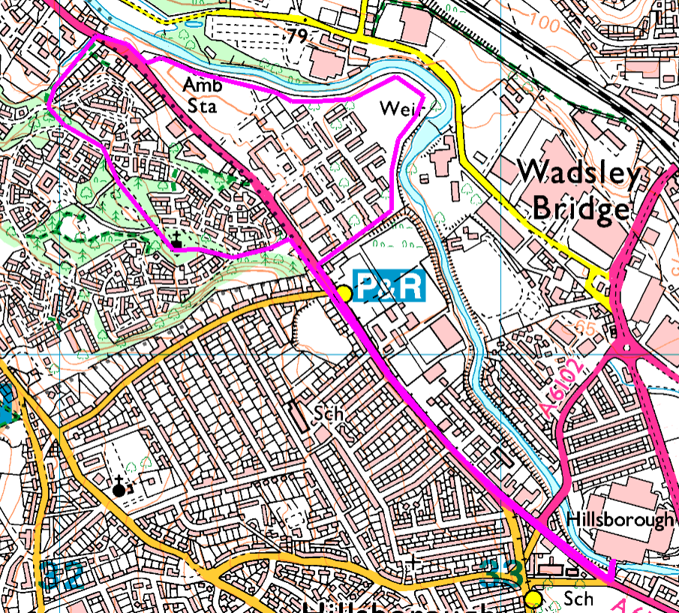
From the stadium, walk (or drive) up to the training ground, then carry on along Middlewood Road to the start of the Wynn Gardens estate. Here we follow the path round the outside of the flats then cross the grass to the river. Follow the bank to eventually return to the road. Cross over with care and walk up the grass and through the trees to Northwood Drive and on to Middlewood Drive. Turn left and walk down before taking the path through the trees into Wadsley Park. Head towards the church and eventually arrive on Middlewood Drive. Head down to find the footpath which cuts through the trees and return to the stadium / training ground along Middlewood Road.
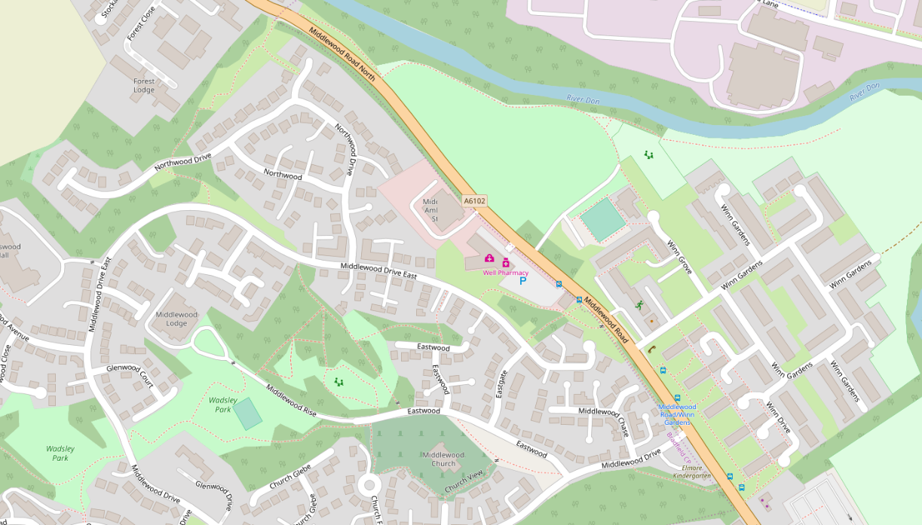
Risks:
- Grass (possible mud, dog dirt, etc)
- Busy road crossings and tram tracks

