Week 10 – Damflask – 2.6 miles.
Starting point: The Dam, Damflask, B6076 New Road, S6 6SQ
Start at 10:00 – 10:30 am at the stadium or 11:00 am at the dam
no toilets, but visiting pub afterwards.
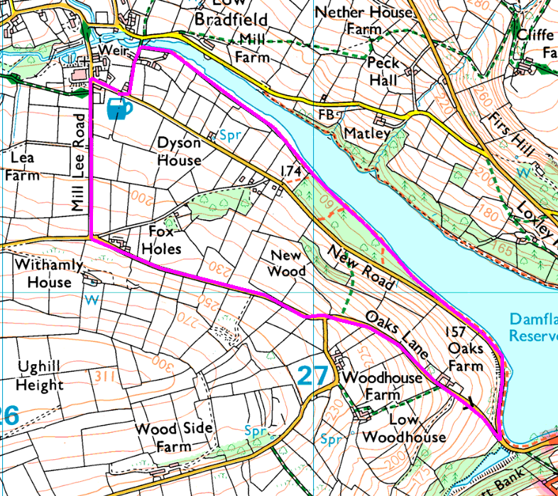
Option for flat walk round the dam, but not as a health walk (Fit Club are doing this longer walk)

Marked walk is a road / lakeside walk, but there are alternatives through the woods and up to Low Woodhouse, which may be muddy in wet weather.

