Week 9 – Stannington – 2.3 miles.
Starting point: Stannington Library, Uppergate Road, Stannington, Sheffield S6 6BX
Steep climb / steps up. Footpath across field may be muddy.
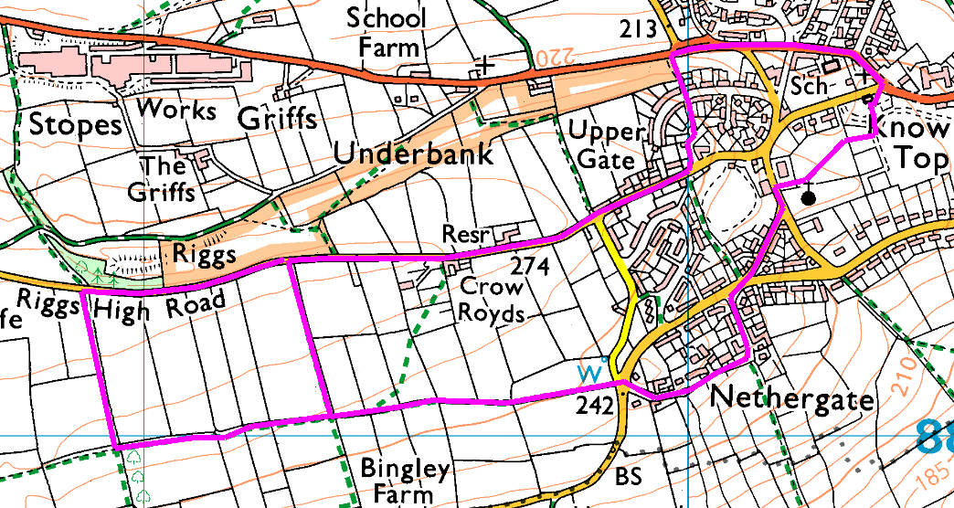
From the library car park , cross Uppergate Road and walk down Stannington Road. Pass Spout Lane on the right, then take the steps on your left which climb steeply up to Highfield Rise. Take your time and admire the view. (to avoid the steps, after the infant school cut through to Sheldon Lane then join the end of Highfield Rise).
Cross Highfield Rise and take the footpath through to Uppergate Road, then turn right and follow to Riggs High Road. After the footpath on the right, take one of the next two footpaths on the left which lead down across the fields. At the bottom of the field, cross the stile and turn left onto the footpath which takes us back to Nethergate.
Take great care crossing this road, then proceed along Nethergate , pausing to admire the view and the old buildings, before crossing Oldfield Road and following School Lane and Church Street to the Lomas Hall. Take the footpath beside the church wall, and either follow into the corner and round past the café (stop here for a rest if you are back early) or diagonally across the field and through the children’s playground, back to the car park.
Short Walks: Round the park, up to the cricket field and through to Nethergate.

Risks:
- Steep steps (warn and show alternative)
- Grassy footpaths (sloping down), mud, stiles
- Road crossings (2 major, several minor) and walk along minor road (no pavement)

Places to pause and ponder
- Views over both sides – can you spot Our Cow Molly?
- Nethergate – the cottage at the end of the road and other buildings along it.

