Week 8 – Clay Wheels Lane – 2.5 miles.
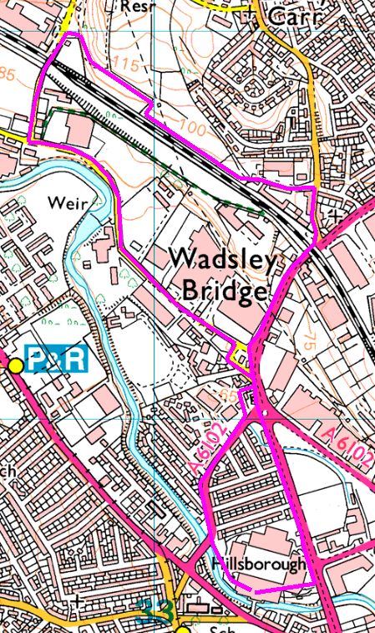
This walk explores footpaths near the end of Clay Wheels Lane. There is a long road walk to start and another at the end, but a pleasant woodland and field walk in between.
Figure of 8
From the stadium, follow Penistone Road up to Sainsbury’s, then turn left. Follow Clay Wheels Lane to the junction with Limestone Cottage Lane and turn right.
Walk up the hill under the bridge and turn right beside a concrete block, across the old car park. In the corner, take the path beside the fence which leads into the trees. Take care here as it is steep and sloping with tree roots and rocks. Go up the path to the edge of the field, then turn right staying within the trees to follow down towards a pylon. Turn right and follow round the edge of the field to the end of Baxter Road.
Walk down the road and turn right at the end, then right at the traffic lights and return to the stadium via Lepping Lane.
There was an alternative footpath until July 2018, but it has been expunged!

Risks
- Long walk beside main road and multiple road crossings.
- Muddy footpaths, tree roots, leaves, etc

Places to pause and ponder
- This area was all heavy industry, driven by the water from the Don. Not much left now but we still get names, especially Niagara and Clay Wheels mills, and the weir at Clay Wheels Forge
- How to expunge a footpath
- The old chapel and funeral home
- Sainsbury’s café (if you need the toilets!)

