Week 7 – Wheata Wood – 2.3 miles.

There are lots of walks round Greno and Wharncliffe Woods, but this one breaks out of the trees to give an excellent view across the Don valley and down to Sheffield. Staying towards the top of the hill, this walk avoids any great climbs and generally is on woodland paths which may be a bit muddy but should not be very slippery unless it snows.
Starting point: Greenoside Woods Car Park, Woodhead Road, S35 8RS
No toilets or refreshment
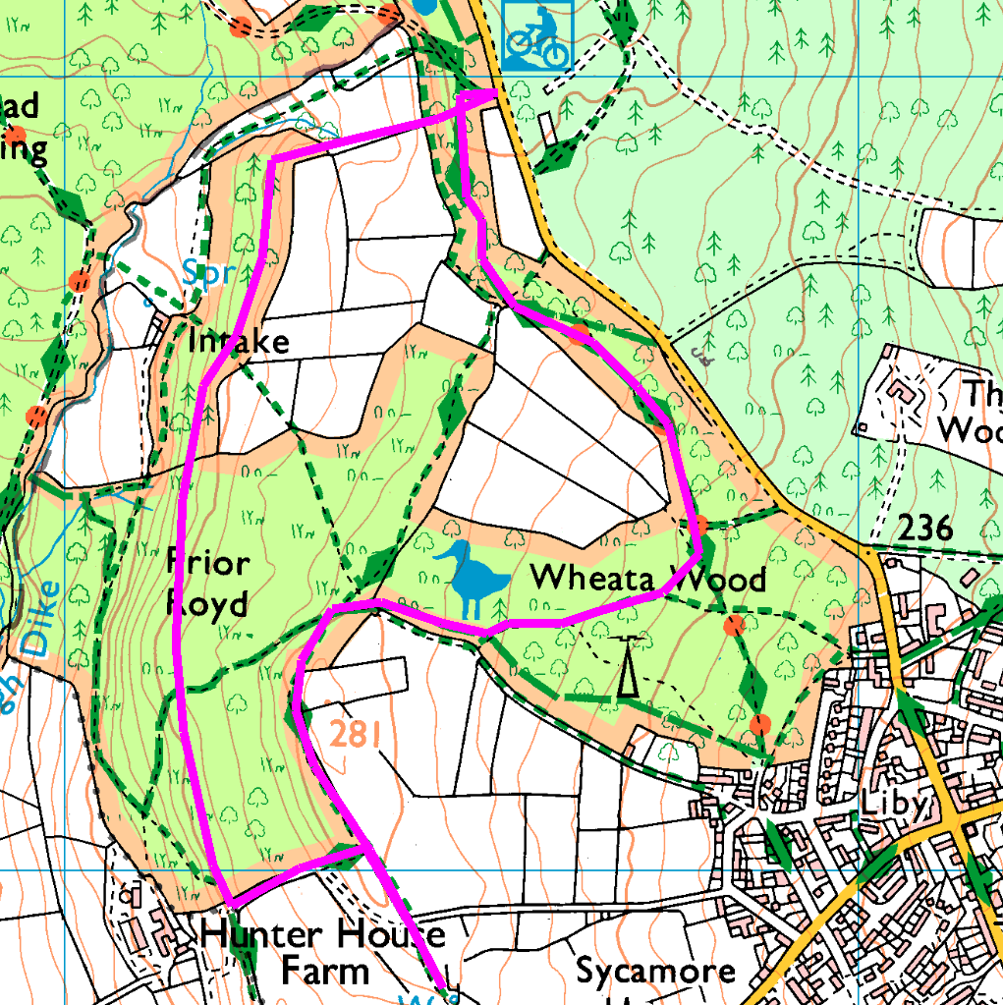
Clockwise
From the car park, head South along the well marked bridlepath, going straight on at the first crossroads then taking the path which turns left round the end of the fields. Follow this path till you see open fields, bearing right to stay in the wood. At the next crossroads, turn left and follow parrallel to the wall and fence, till you leave the wood where the wall turns right, and go straight on across the field to the viewpoint and bench at the top of the hill.
Retrace your steps to the wood, and turn left to follow the wall downhill, before turning right and entering the wood. Take the central path (the most level), and follow this round the side of the hill through the trees. When you reach the end of the trees, leave the wood and follow the path across the (muddy) stream and up to the stile where you re-enter the trees. Climb the steep slope straight ahead and rest on the bench / bird feedr before getting back in your cars.
Risks:
- No roads
- Footpaths and bridlepaths – horses, dogs, cycles (not too popular with cyclists), tree roots, etc.
- Mud, wet leaves, slippery if wet.
- STILES (4) (can be avoided).
Places to pause and ponder
- The viewpoint at the top of the hill, and also just before you re-enter the wood near Hunter House
- Whale jaw bone hill – shown as Whalejaw Hill on the map, locals call it jawbone hill. Now no sign of a whale jaw!
- Cote d’Oughtibridge – anybody fancy cycling up that hill?

