Week 5 – Wadsley and Loxley Common – 2.2 miles.
The walk shown on the map is the longest route that can be taken, but as it is all open access land with a multitude of official and unofficial footpaths, the biggest risk is in getting lost.
Starting point: Wisewood Sports Centre / Old Library Café, 75 Laird Rd, Sheffield S6 4BS
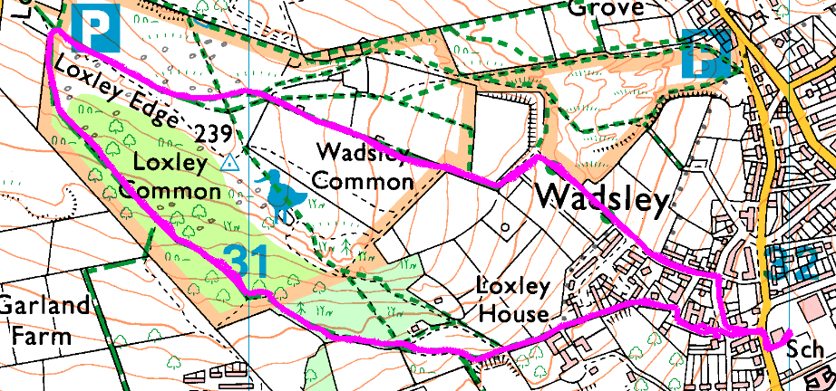
Clockwise
Lead by Graham.
Risks
- Crossing roads (2 crossings) and access road to the top car park
- Steep climbs and descents
- Will be muddy
- Dogs and their walkers
Places to pause and ponder
- The view. Splendid view of the Loxley Valley.
- Burnt out area – good or bad? (if you go that way)
- Apple trees

