Week 4 – Oxspring – 2.2 miles.
This road walk is quite hilly with a steep descent.
Anticlockwise
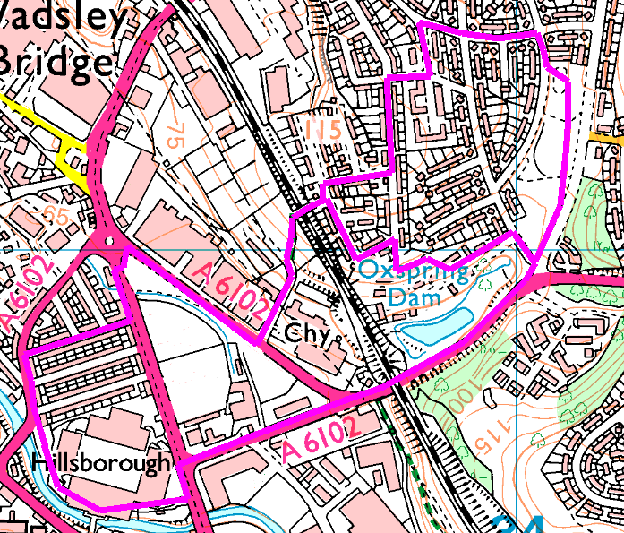
From stadium, cross Penistone Road and head up Herries Road. After the junction, cross over to the left and look in at Oxspring Dam – now a private fishing pond. Head on up the hill and turn left, cross the end of Cookson Road and walk up Wordsworth Avenue before dropping down to the far corner of Cookson Park. Turn right and left up Avisford Road then left and right and left again onto Binstead Grove, right onto Binstead Glade, left onto Binstead Way and right onto the footpath over the railway.
(Shortcut, saves 0.5 mile: Immediately after turning left off Herries Road, turn left onto Cookson Road and left again into Oxspring Bank. Look out for a path on the right taking you through to the end of Binstead Grove then turn left into Binstead Way. Turn left onto the footpath over the railway.)
Follow the footpath and Wardsend Road before turning right onto Herries Road (North). Cross over and cut through the woods at the corner, then cross back over Penistone Road and head down Vere Road to enter the stadium from Lepping Lane side.
Risks
- Crossing busy roads (4 road crossings)
- Steep descent
- Fly tipping
Places to pause and ponder
- Herries Road Railway Viaduct (Five Arches): Built by the Manchester, Sheffield and Lincolnshire Railway which became the Great Central Railway in about 1850. When originally built, the track under the bridge was at the same level as the cottages, but it was raised to reduce the slope when the road was built in the 1920s.
- Oxspring Dam : used to be the dam for a water-wheel and barking mill on the other side of the railway embankment . This was part of a tannery just behind the two old cottages on the corner (tree bark was used to make tannin, which is used to tan leather). The pond is fed by a stream called Toad Hole Dyke that starts from a spring somewhere in the region of the old Ritz cinema (now demolished). The dyke/stream was covered over when Cookson Park was developed.
- The railway footbridge – you are about to start a steep descent, which means you get a good view!
- Vere Road – a typical Victorian terrace, compare with the 1930s council houses we saw earlier.

Comments
Threw away the plan, went up Herries Road, along beside river and climbed Shirecliffe hill again, then returned via Binstead Way. Great walk.

