Walk 3 – Rivelin Valley
This walk starts at the Rivelin Café, but for a longer version you can start from Walkley Tilt car park (height restriction 2 metres!). Park on the road near the café entrance. The maximum length is 2.2 miles (or 3 miles from the Tilt) with a couple of steep hills, but there are many options.
Clockwise
From the café, follow the path up the hill and back down to the bridge, before heading upstream with the river on your right. Follow this path till it ends on the main road, near the bridge. Cross the road with care, then cross the bridge and go down the steps to end up between the river and a mill race. Keep on this path to the first mill pond – a large pond with paths on both sides. Bear right, up to the road and cross into Tofts Lane – a steep climb with a pub at the top.
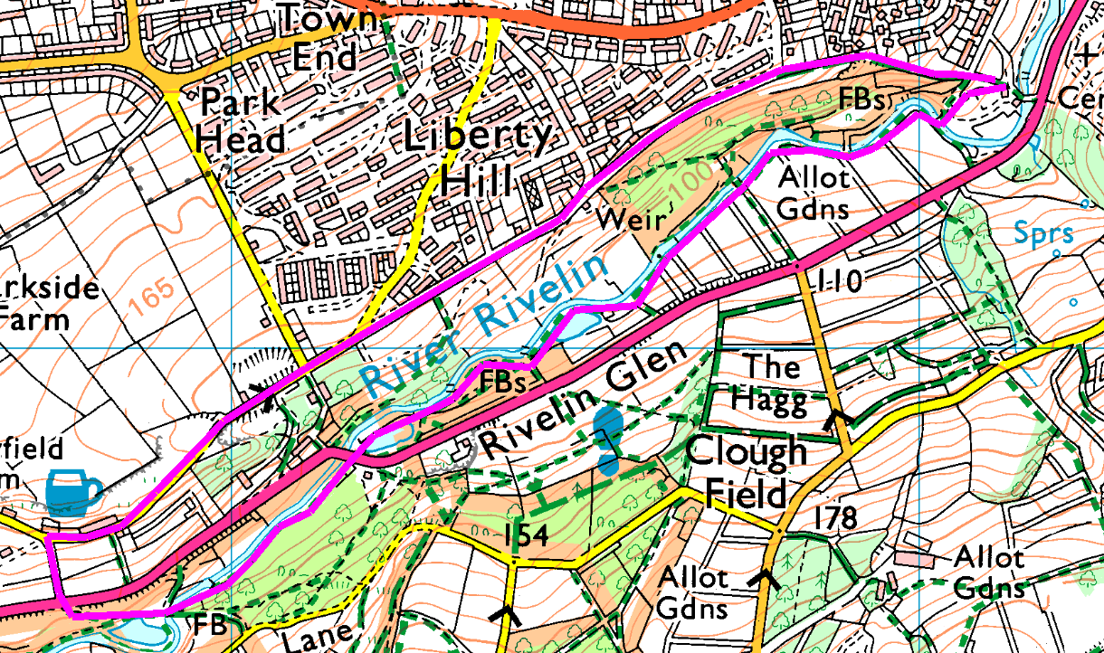
Turn right in front of the pub and follow the road up hill, then down past the quarry. When the road bears left, go straight on along Roscoe Bank, skirting the bottom edge of Stannington. Just follow this road till it turns away from the trees, then take the path on the right which drops you back down to the Café.
Shortcuts: There are three paths up from near the road bridge which all save you crossing the road. The first is just sfter the bridge, leading back through the wood before climbing up to the road, whilst the other two both climb more directly – the footpath using steps in places while the bridlepath is not quite as steep and uses the old quarry access roads. Any of these cuts off about half a mile.
Risks
- 2 road crossings, one on an awkward bend.
- Return is along a narrow road with blind summits – watch out for idiots.
- Steep climb – can only be avoided by returning along the riverbank.
- Wet, muddy underfoot (even in summer).
- These paths are frequently walked by the Stannington group.
Places to pause and ponder
- The industrial heritage of the river, with its mill ponds and weirs.
- The seat and stepping stones
- The Rivelin Hotel (catch your breath and admire the view)
- The quarry

