Week 2 – Owlerton – 2.2 miles
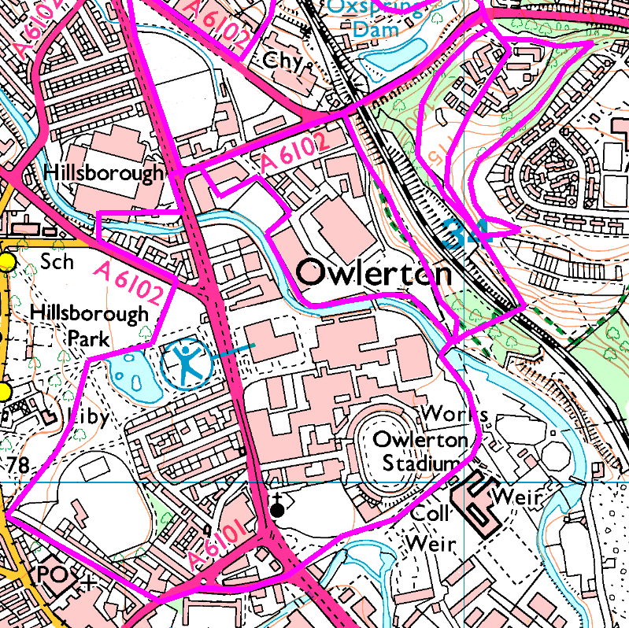
Week 2 takes us off the road and onto some footpaths, looping round Owlerton in the process. Again, there are 3 options with the longest coming in at 2.2 miles.
Anticlockwise
All the routes start by going through the park and down Hawksley Rd and Bradfield Rd before crossing the dual carriageway on to Livesey St, passing the casino, the College and Owlerton Stadium. Follow round to the entrance to the Mondelez / Cadbury factories and on over the blue bridge across the Don.
Here we have three choices.
Route 1 – Riverside – 1.75 miles total
This footpath is noisy and will flood if the river is high, going under 2 private bridges owned by Mondelez / Cadbury to join their factories either side of the river.
Turn left immediately after the bridge and follow the riverside footpath to Rawson Spring Rd. Turn left past Hardcore then left again to go through Hillsborough Trade Point and emerge onto Herries Road. Turn left and return to the stadium.
Route 2 – Todd Hall Dyke – 1.8 miles total
Go straight ahead over the bridge, past the scrap yard before turning left under the electric pylons. Follow this well marked path till you see the footbridge; go on a few yards then carefully double back beside the dyke, cross the bridge and return on the footpath on the other side. At Herries Road, turn left and back to the stadium.
Take care beside the dyke, as this part of the path is narrow and not level; it may be slippery if wet.
Route 3 – Scraith Woods – 2.2 miles total
After the blue bridge, go straight ahead up through Wardsend Cemetry to the railway bridge. Cross this and turn left, up a steep, stepped climb. At the top bear right then turn left at the junction to follow further away from the edge or bear left along the edge of the cliff (carefully) to the concrete blocks. Stop to admire the view before continuing along the path, avoiding the steep descents, to emerge onto Scraith Wood Drive, then turn left to Herries Road. (if you come out onto a footpath with a handrail, you are too high – turn left and follow down to Herries Road). Follow Herries Road under the 5 arches and back to the stadium.
Risks
- Crossing busy roads (4 road crossings)
- Footpaths (mud, slipping, tree roots, steps, etc)
- Fly tipping and burnt out cars
- Routes 1 and 2 –
  - River / stream banks, flooding, etc.
  - In flood conditions, untreated sewage may be discharged into the dyke and the river.
- Route 3
  - Steep climb and descent.
  - Keep clear of the cliff edges.
Places to pause and ponder
- River Don and the blue bridge
- Smell the Liquorice (route 1)
- Herries Road Railway Viaduct (routes 2 and 3)
- Route 3
  - The view. Splendid view of SWFC stadium and Hillsborough in general.
  - Wardsend Cemetery. This approach does not show the full size of the cemetery, but you can still see the number of headstones, most of which are over a hundred years old but still quite legible.

Comments
Did not bother with short options – everybody went big and enjoyed it. Quite a climb up from the cemetery, but well worth it. Took new photo for the poster.
