Walk 01 – Beyond Morrisons – Up to 3 miles.
Starting point: SWFC Stadium
This is an introductory walk to see how far people actually want to walk. It is a rectangular route with 7 possible shortcuts to give anything from a walk round the park lake to one that pushes the 3 mile limit.
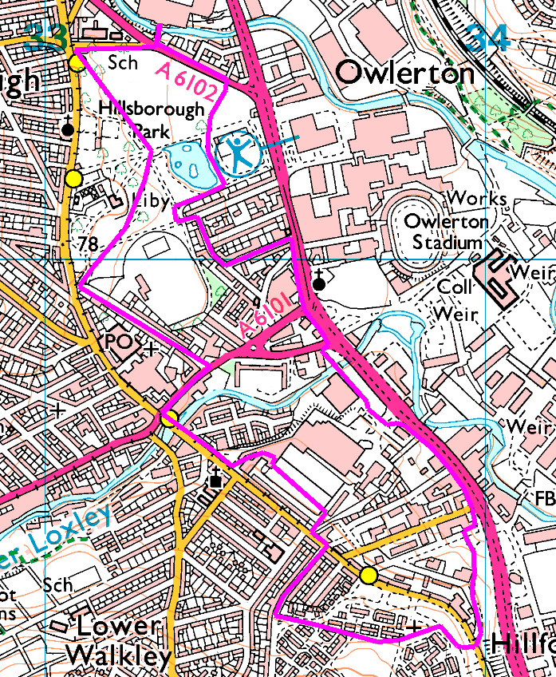
Risks:
- Several major road crossings – all have lights, except the very longest walk crossing Infirmary Road (twice).
- Walking through shoppers / past bus stops, etc.

